

# D&T II

# D03: Performance testing

# **Performance test suite**

# Group 20

**Candelario Luna, Luis**

**Carrasco Márquez, Antonio**

**Gil Guerrero, Luis**

**Márquez Orellana, Francisco**

**Morales Moreno, Sergio**

**Moreno Ruiz, Juanma**

Content

Introduction: 3

Performance tests: 4

Requisite: 7.1 4

Analysis results: 9

Requisites: 7.2, 7.3 10

Analysis results: 14

Requisite: 7.4 15

Analysis results: 21

Requisites: 7.1, 8.1, 8.2 22

Analysis results: 27

Requisite: 9.1 28

Analysis results: 32

Requisite: 9.2 33

Analysis results: 38

Requisite: 9.3 39

Analysis results: 45

Requisite: 10 46

Analysis results: 52

Requisites: 11.1, 11.2, 18.1 53

Analysis results: 60

Requisite: 17.1 61

Analysis results: 66

Requisite: 17.2 67

Analysis results: 72

Requisite: 23.1 73

Analysis results: 78

Requisite: 23.2 79

Analysis results: 84

Requisite: 24.1. 24.2, 24.3, 24.4 85

Analysis results: 92

Conclusion 92

# Introduction:

To test all user cases for Acme-Hacker-Rank we used Jmeter with the following method:

* Group some requisites to do the testing to be more efficient.
* A test with 100 users and 10 loops to see if there is any error in the code.
* A test with a number between 130 and 180 users to see the maximum users that supports the actions without any problem relative to the user experience, in this case we are going to check the time spend to do the actions, looking at the 90% Line results.
* A test with the first errors encountered and the most probably reason that made that errors occur. Checking the computer performance we will observe the processor, memory, disk and network behavior.

All the test were made with the same computer in the pre-production virtual machine, with 4 GB of ram and a 2 core processor.

The computer specifications are:

* CPU: Intel core I5 7200u
* Mainboard: Medion D15KHN
* Memory: 8 GB DDR3
* Graphics: Nvidia Geforce GTX 950M
* 245 GB SSD

# Performance tests:

## Requisite: 7.1

7. An actor who is not authenticated must be able to:

1. Register to the system as a hacker.

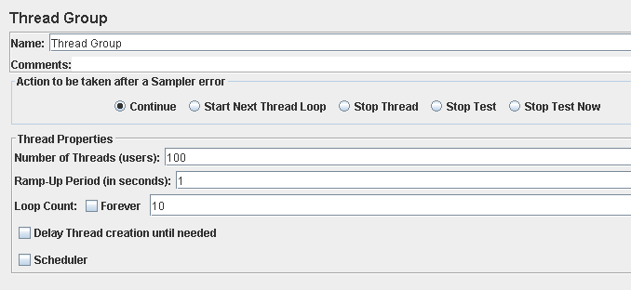

Performance test 90% results: Total 9,879s.

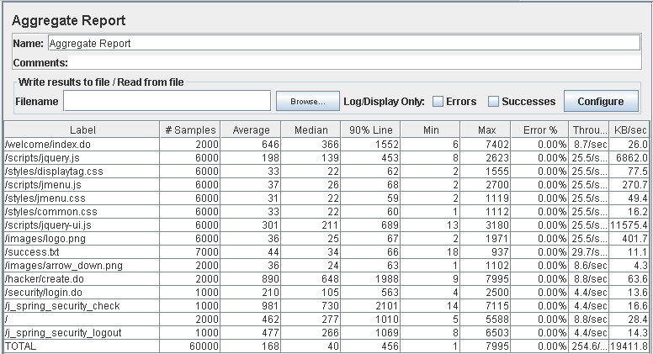

Performance thread results: 15,273 per minute

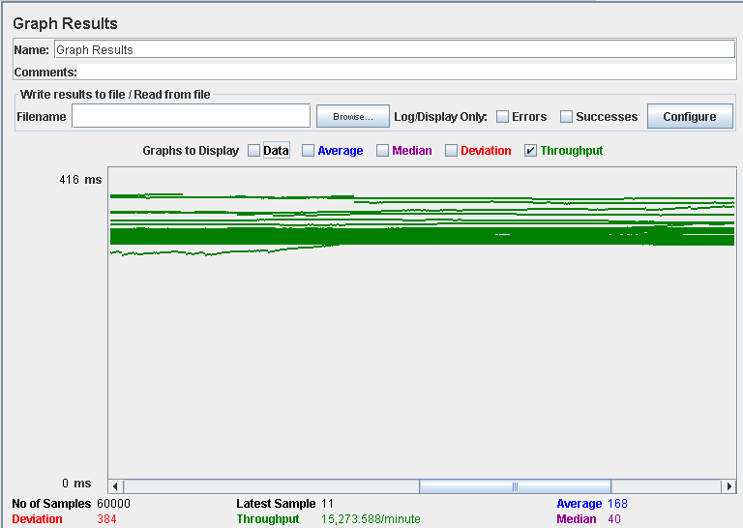

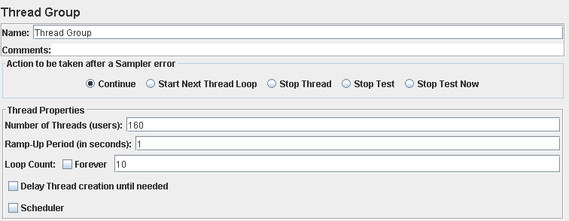

Performance test 90% results: Total 20,851s

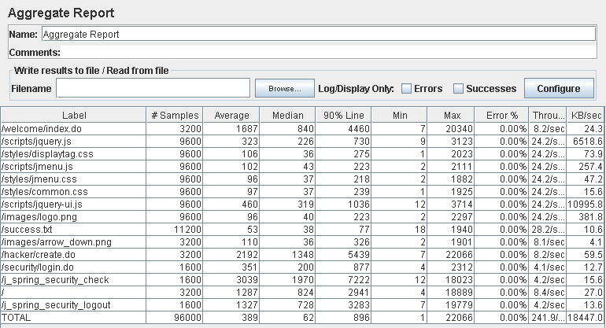

Performance thread results: 14,513 per minute

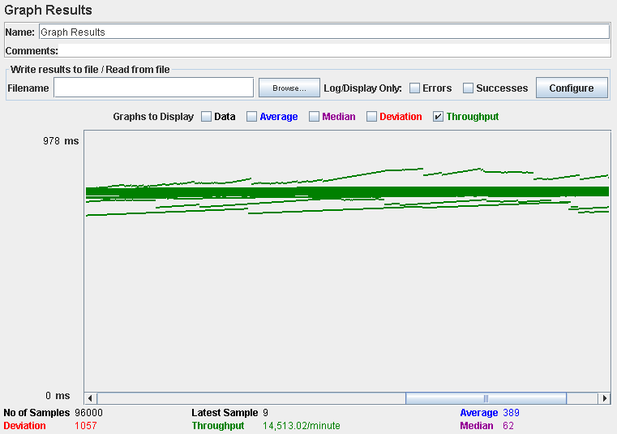

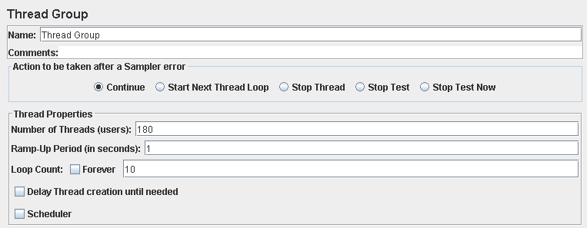

Performance test 90% results: Total 26,860s

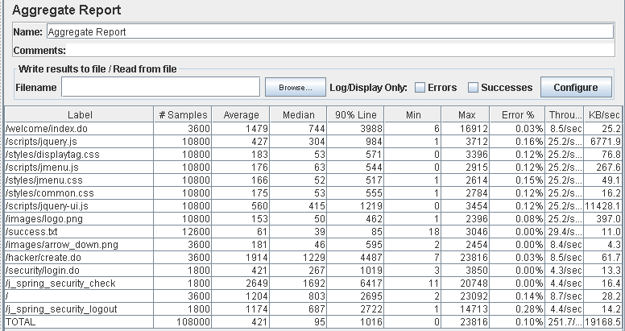

Performance thread results: 15,100 per minute

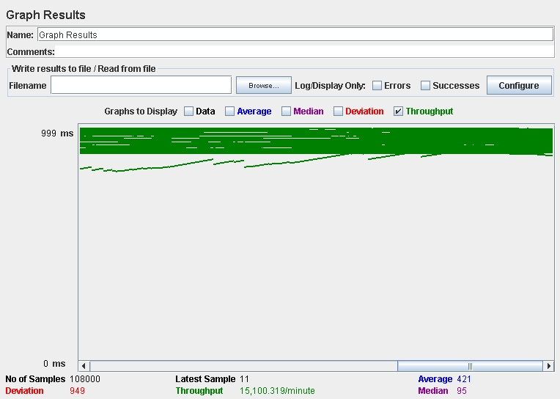

Computer performance:

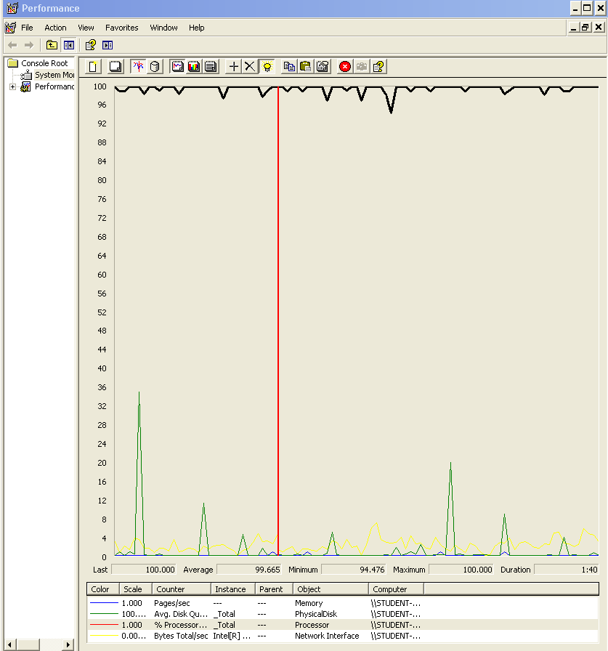

### Analysis results:

100 users and 10 loops: the application runs perfectly

160 users and 10 loops: the application runs without errors but the times are really high (7200ms).

180 users and 10 loops: the application begins to have errors we believe is a processors bottleneck problem.

## Requisites: 7.2, 7.3

7. An actor who is not authenticated must be able to:

2. List the positions available and navigate to the corresponding companies.

3. List the companies available and navigate to the corresponding positions.

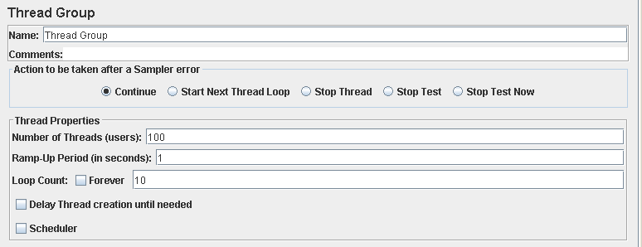

Performance test 90% results: Total 11,625s.

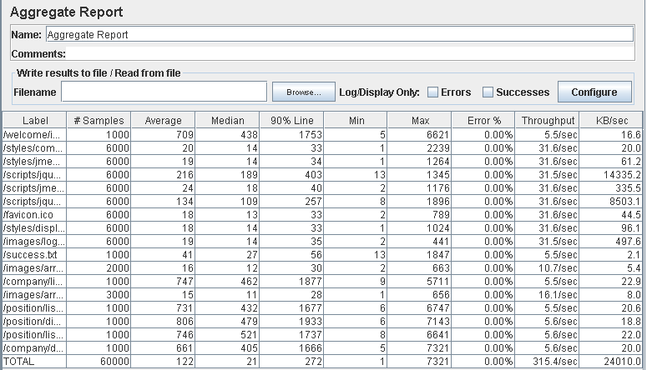

Performance thread results: 18,922 per minute.

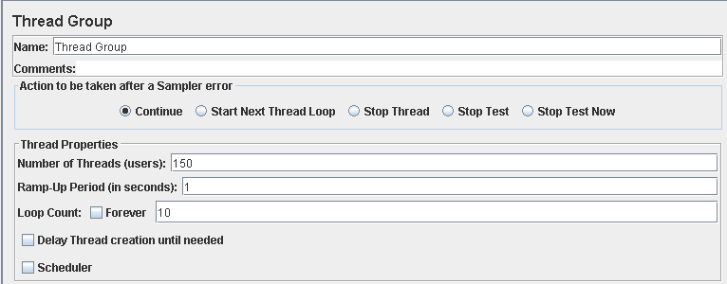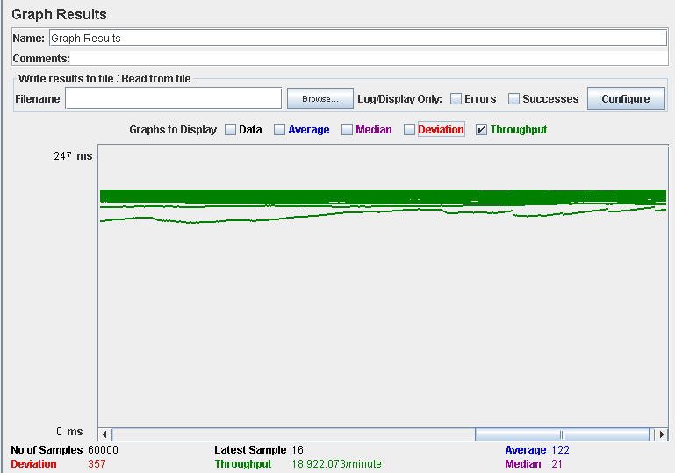

Performance test 90% results: Total 32,536s.

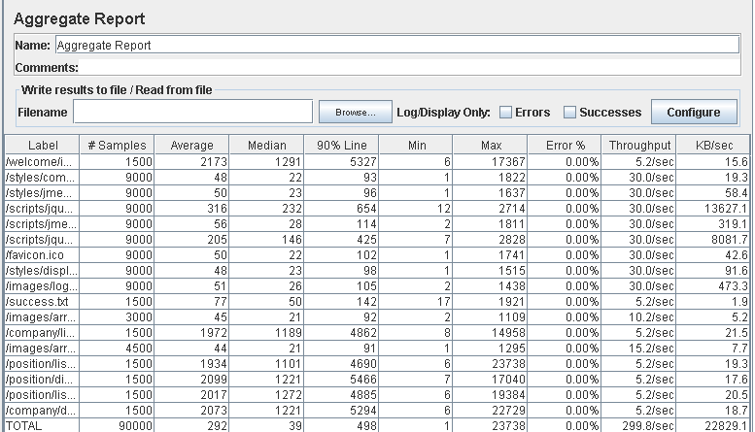

Performance thread results: 17,989 per minute.

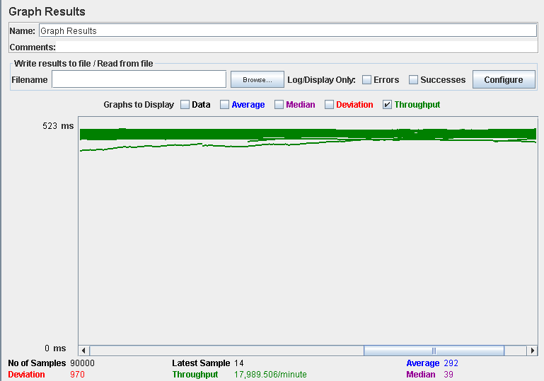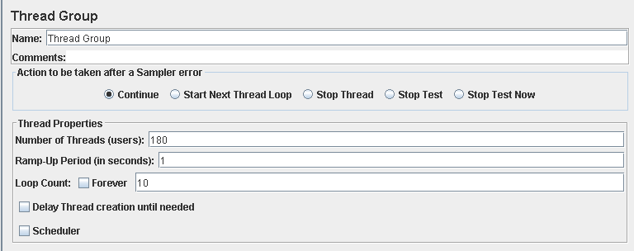

Performance test 90% results: Total 22,829s.

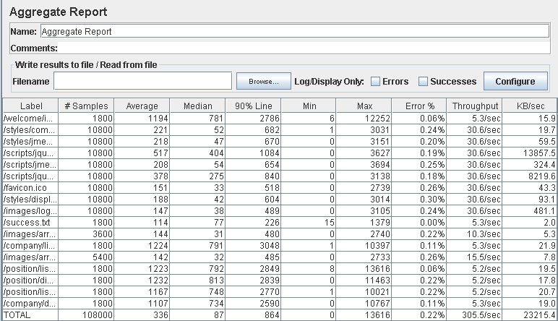

Performance thread results: 18,327 per minute.

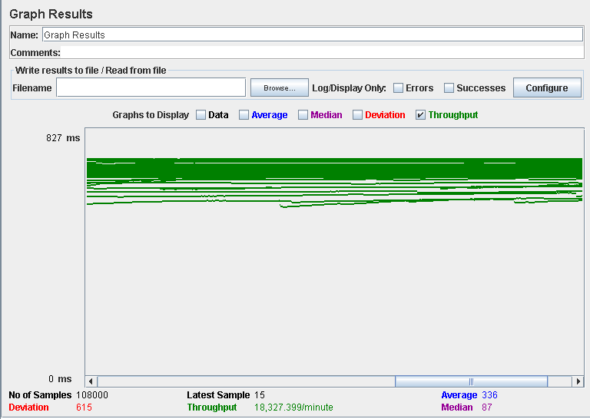

Computer performance: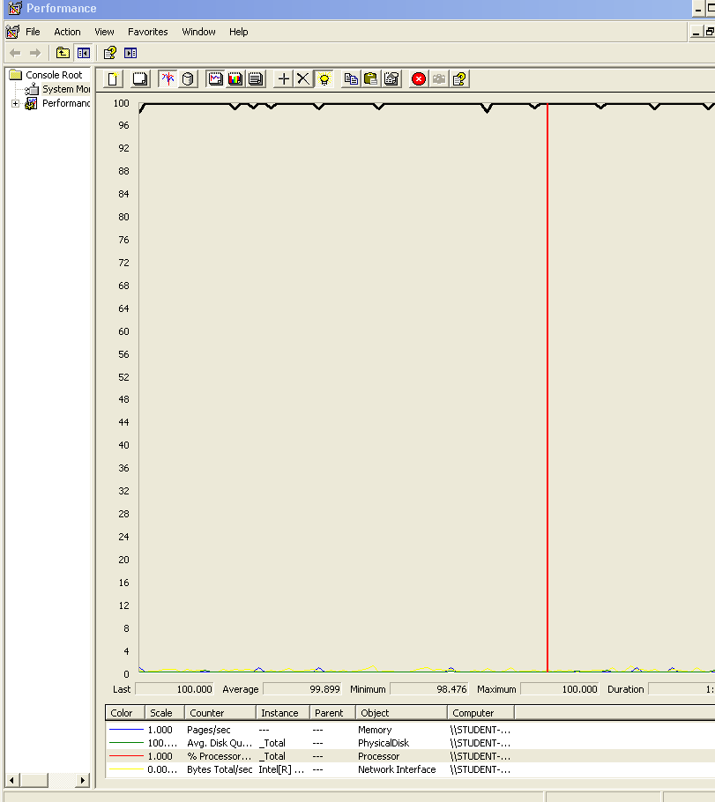

### Analysis results:

100 users and 10 loops: the application runs perfectly

150 users and 10 loops: the application runs without errors but the 90% line shows that listing the positions and companies requires a lot of time.

180 users and 10 loops: it begins to happen some errors, after reviewing the computer analysis results, we believe is a processor bottleneck problem.

## Requisite: 7.4

7. An actor who is not authenticated must be able to:

4. Search for a position using a single key word that must be contained in its title, its description, its profile, its skills, its technologies, or the name of the corresponding company.



Performance test 90% results: Total 3,148s.

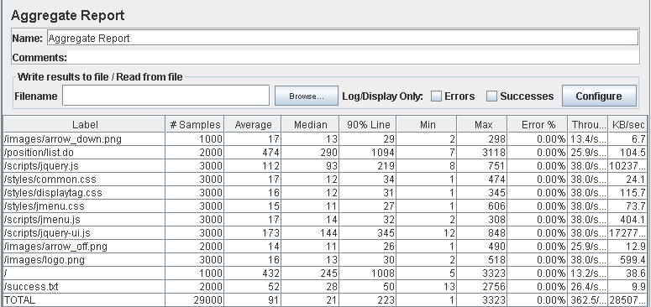

Performance thread results: 21,749 per minute.

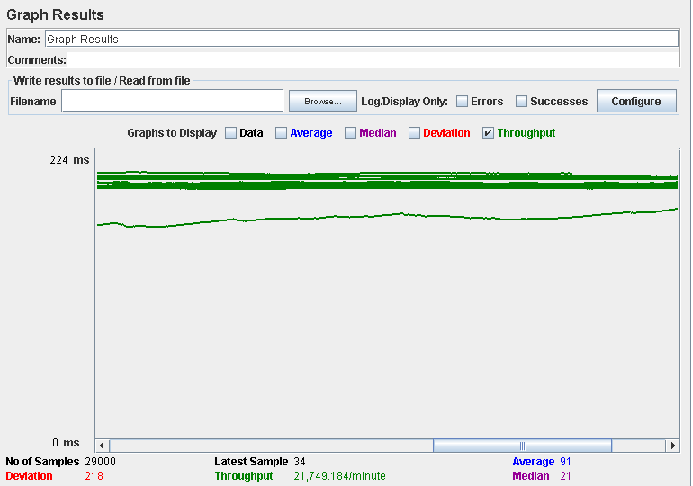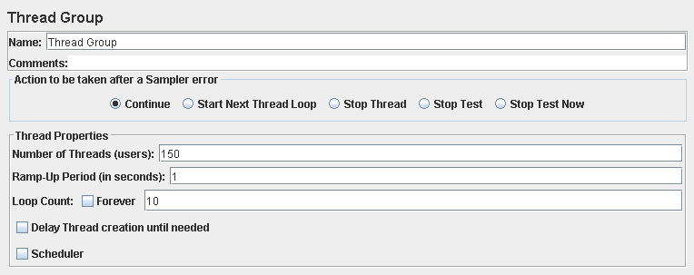

Performance test 90% results: Total 10,302s.

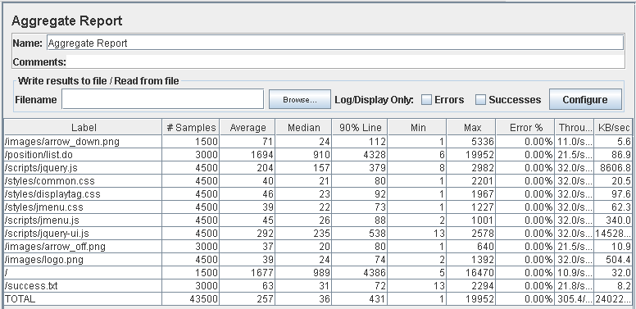

Performance thread results: 18,326 per minute.

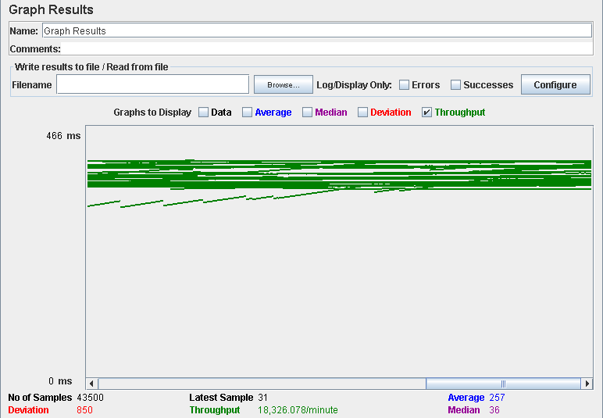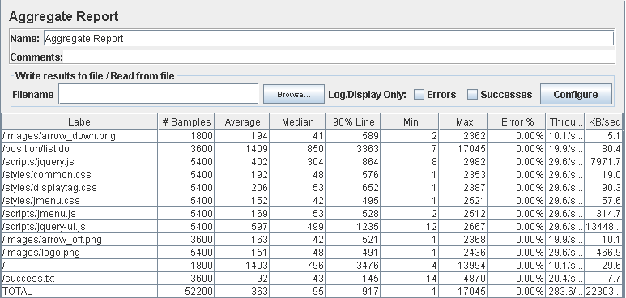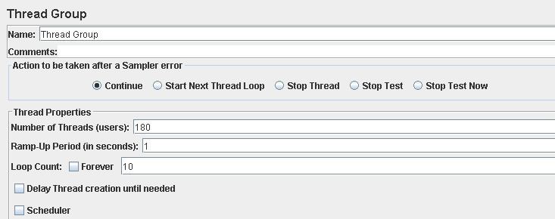

Performance test 90% results: Total 13,832

Performance thread results: 17,014 per minute

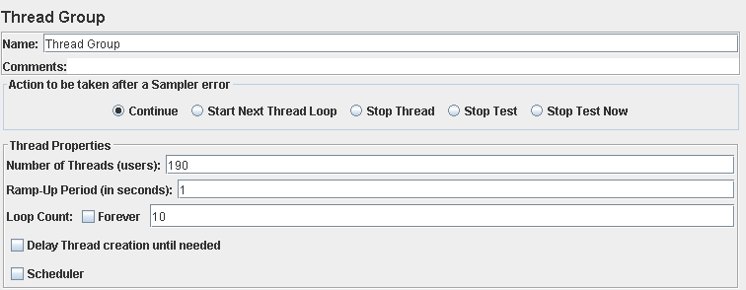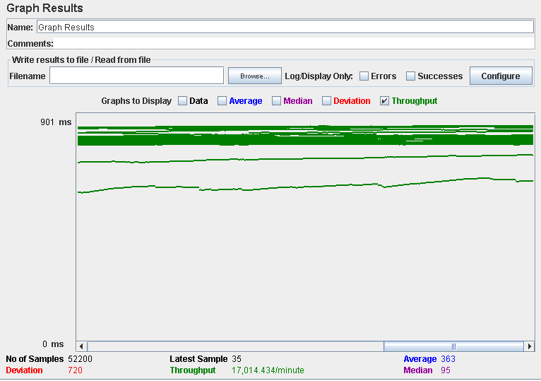

Performance test 90% results: Total 12,037

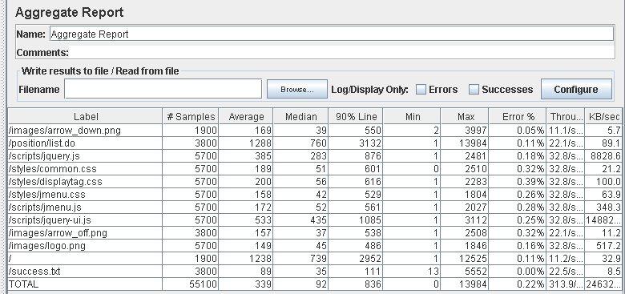

Performance thread results: 18,931 per minute.

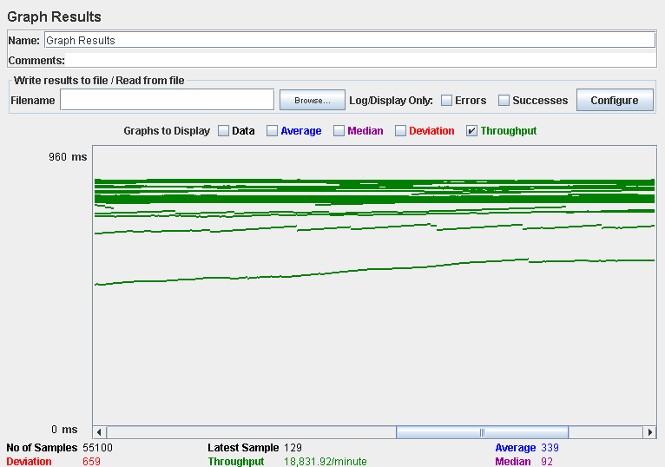

Computer performance:

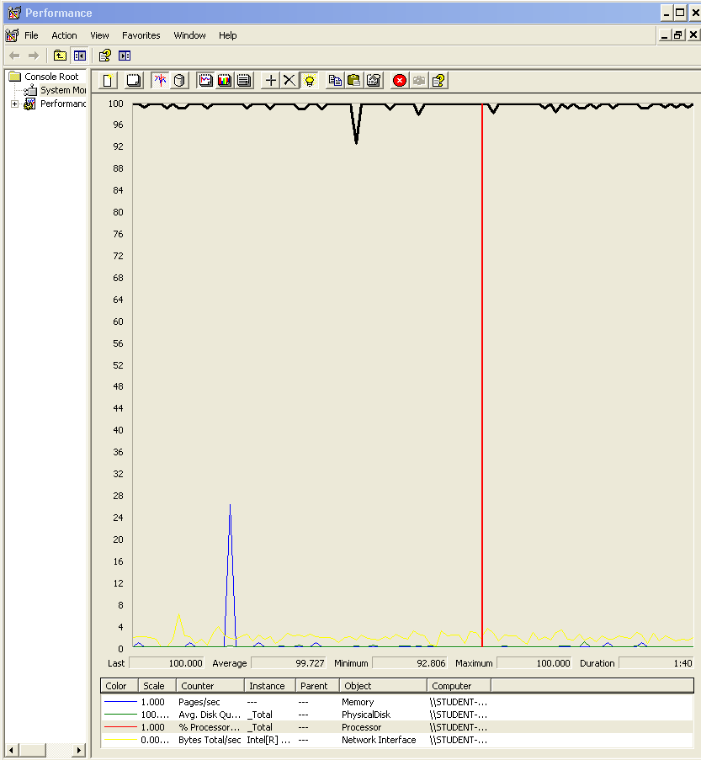

### Analysis results:

100 users and 10 loops: the application runs perfectly

150 users and 10 loops: the application runs without errors but the 90% line shows that listing the finder and going to the welcome view requires a lot of time.

180 users and 10 loops: the application runs almost the same as with 150 users and 10 loops

190 users and 10 loops: it begins to appear some errors, we captured the computer performance for that test and we think that it was a bottleneck problem with the processor.

## Requisites: 7.1, 8.1, 8.2

7. An actor who is not authenticated must be able to:

1. Register to the system as a company.

8. An actor who is authenticated must be able to:

1. Do the same as an actor who is not authenticated, but register to the system

2. Edit his or her personal data.

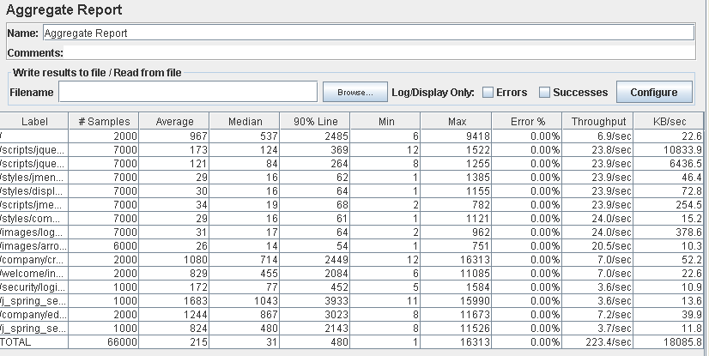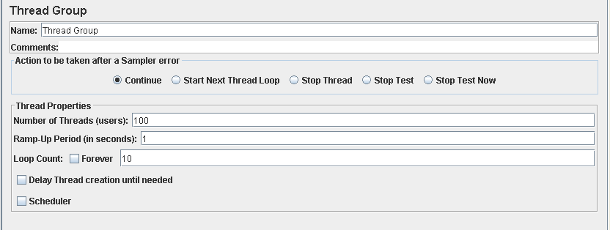

Performance test 90% results: Total 17,575s.

Performance thread results: 13,404 per minute.

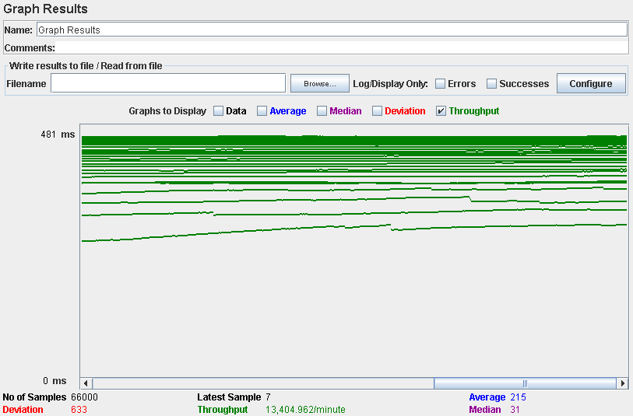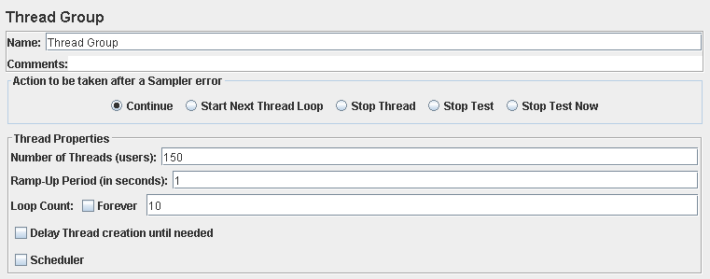

Performance test 90% results: Total 58,645s.

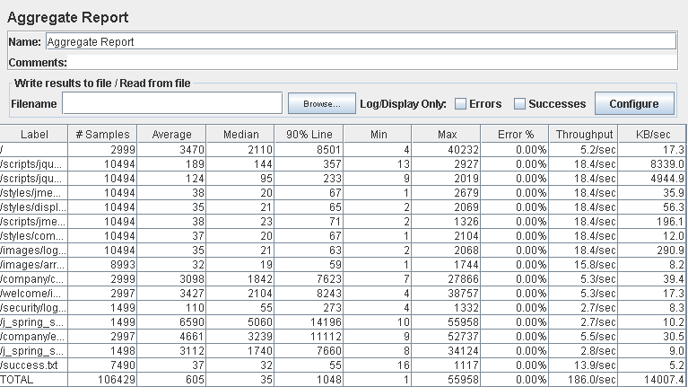

Performance thread results: 11,027 per minute.

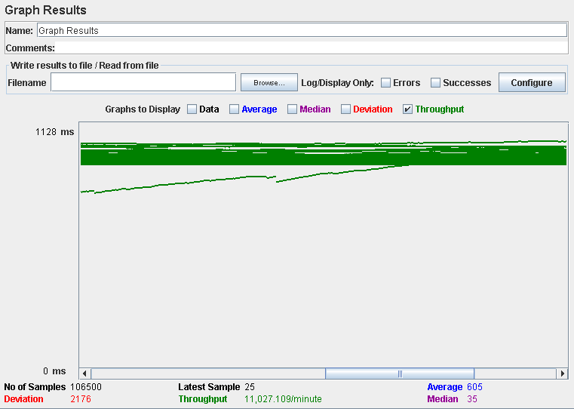

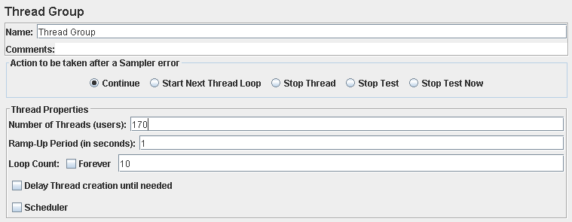

Performance test 90% results: Total 67,730s

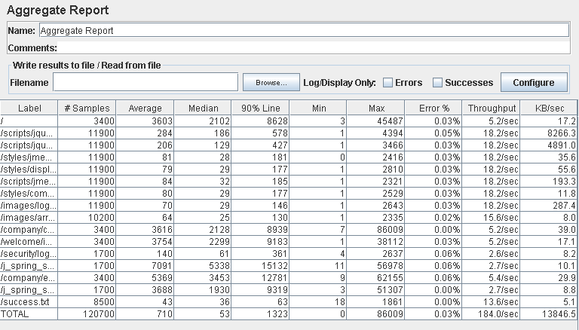

Performance thread results: 11,670 per minute.

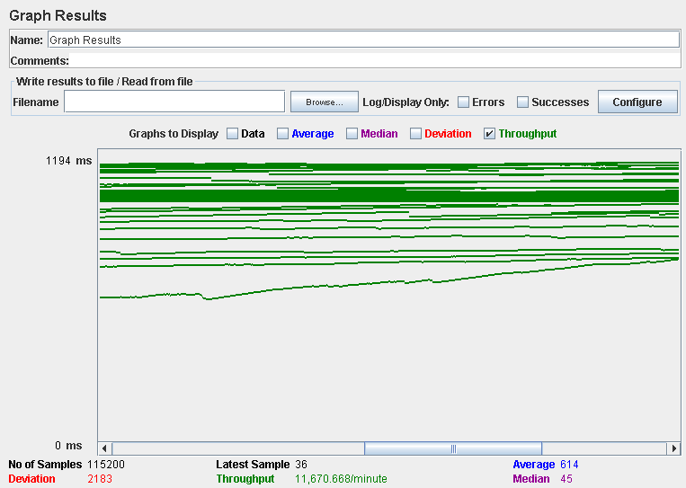

Computer performance:

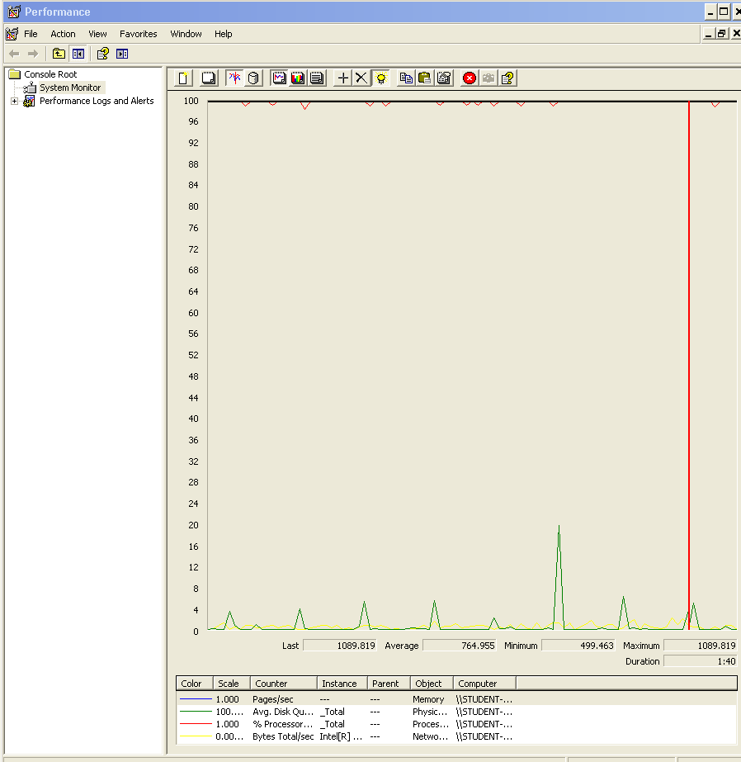

### Analysis results:

100 users and 10 loops: the application runs without errors but the edit and security check times are a bit high

150 users and 10 loops: the application runs without errors but the times are really high.

170 users and 10 loops: the application begins to have problems, the computer performance shows complications, we think is a memory bottleneck problem.

## Requisite: 9.1

9. An actor who is authenticated as a company must be able to:

1. Manage their positions, which includes listing, showing, creating, updating, and deleting them. Positions can be saved in draft mode; they are not available publicly until they are saved in final mode. Once a position is saved in final mode, it cannot be further edited, but it can be cancelled. A position cannot be saved in final mode unless there are at least two problems associated with it.

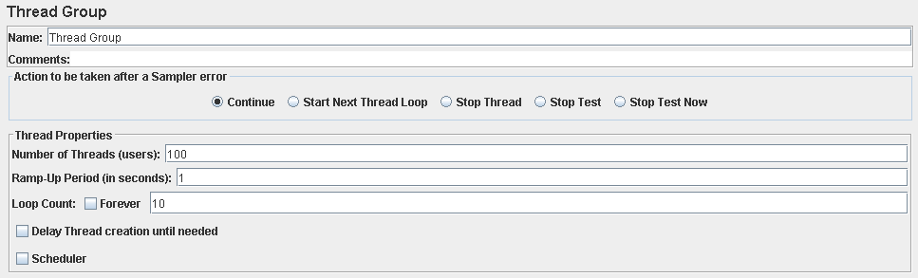

Performance test 90% results: Total 13,727s.

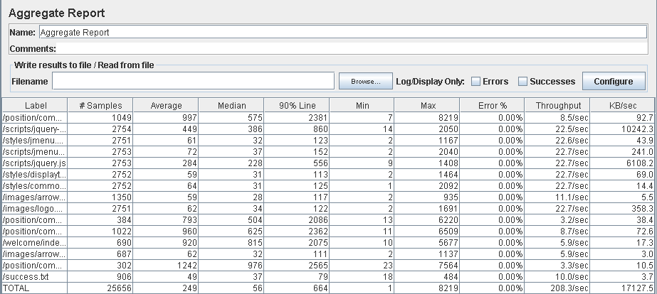

Performance thread results: 12,836 per minute.

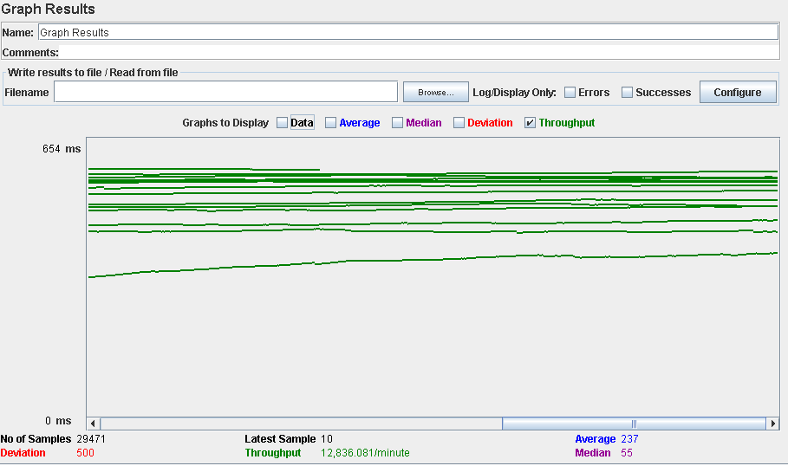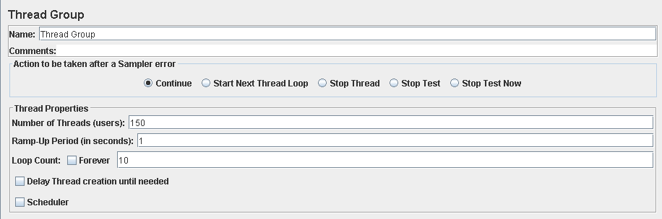

Performance test 90% results: Total 13,570s.

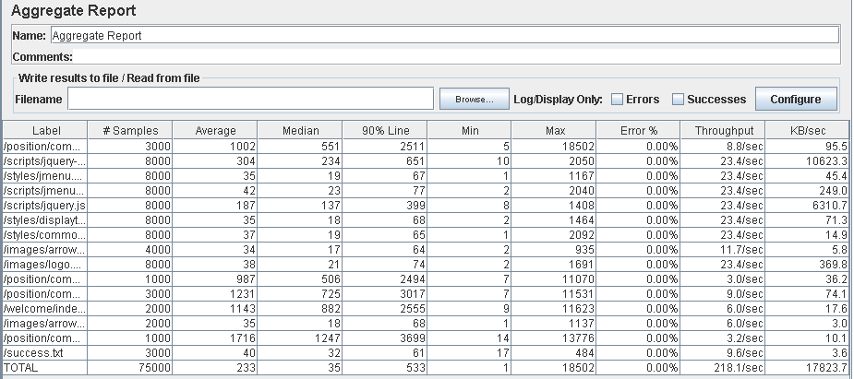

Performance thread results: 13,088 per minute.

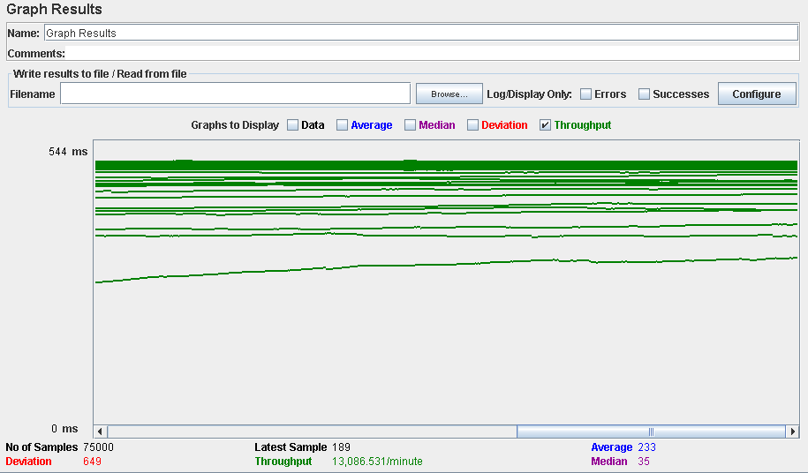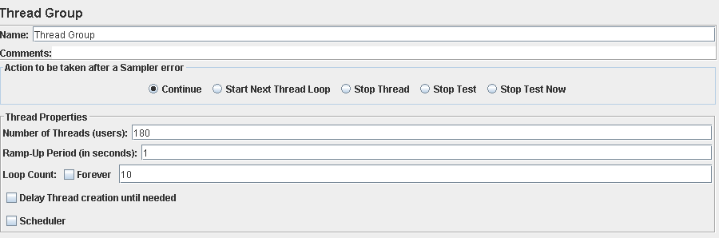

Performance test 90% results: Total 53,814s.

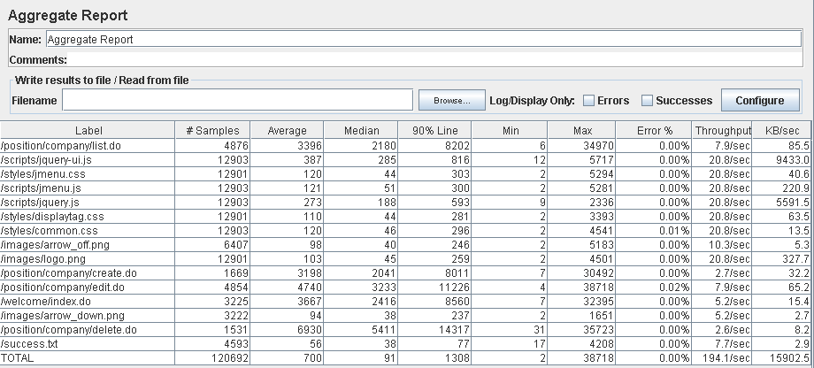

Performance thread results: 11,690 per minute.

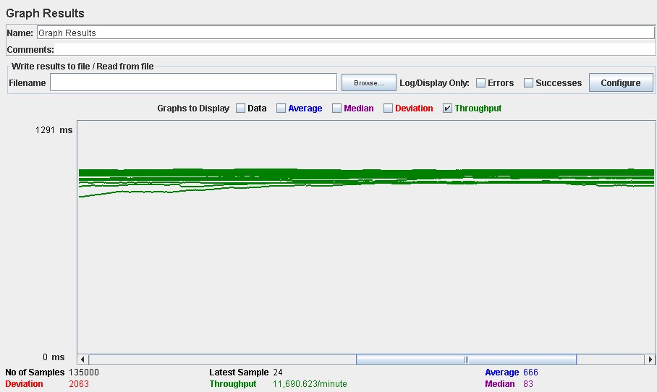

Computer performance:

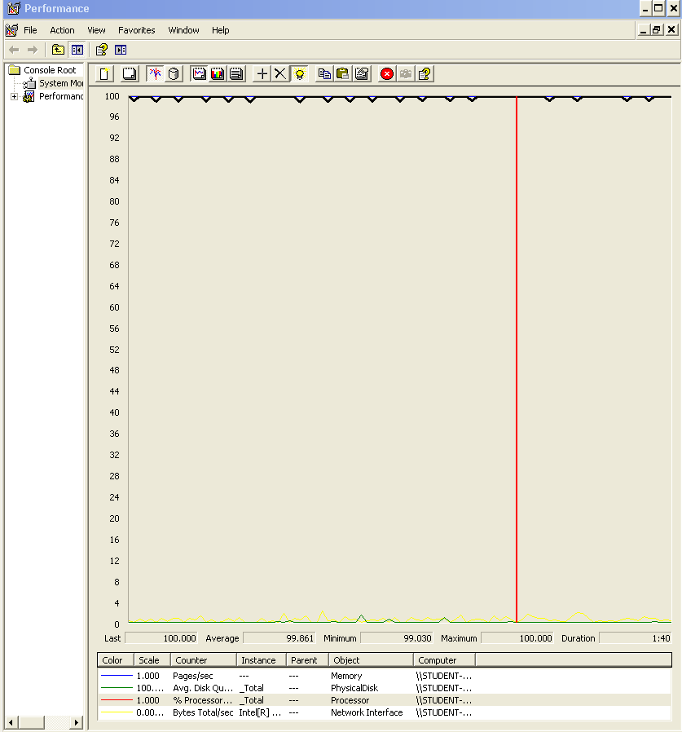

### Analysis results:

100 users and 10 loops: the application runs perfectly

150 users and 10 loops: the application runs without errors but the times are a bit high (3600ms).

180 users and 10 loops: the application begins to have errors, we believe is a memory or a processors bottleneck problem.

## Requisite: 9.2

9.2. Manage their database of problems, which includes listing, showing, creating, updating, and deleting them. Problems can be saved in draft mode; once they are save in final mode, they cannot not be edited.

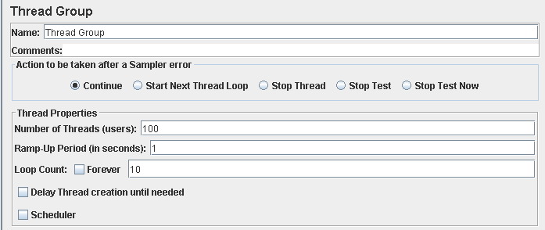

Performance test 90% results: Total 7,422s.

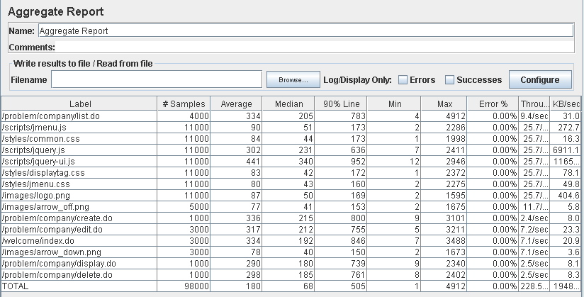

Performance thread results: 13,707 per minute.

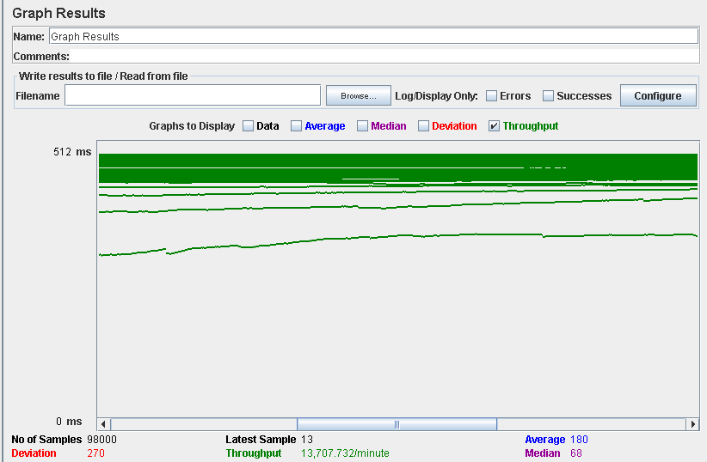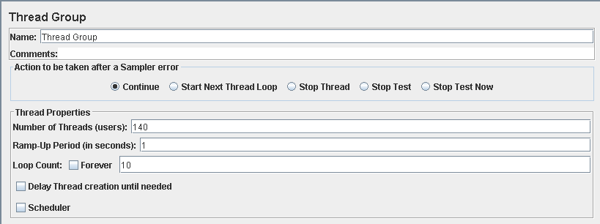

Performance test 90% results: Total 11,814s.

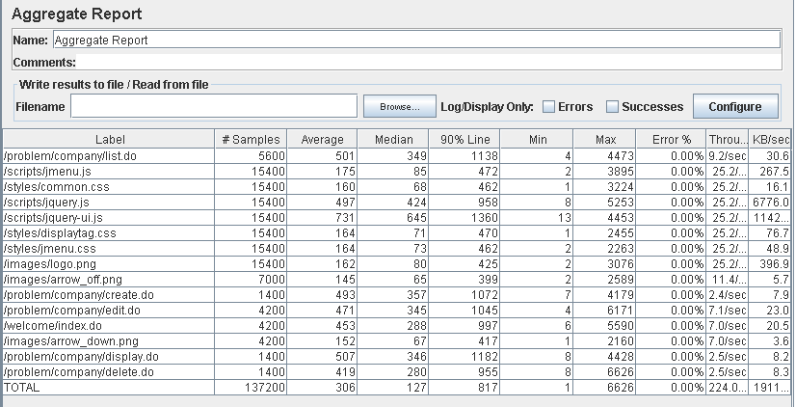

Performance thread results: 13,442 per minute.

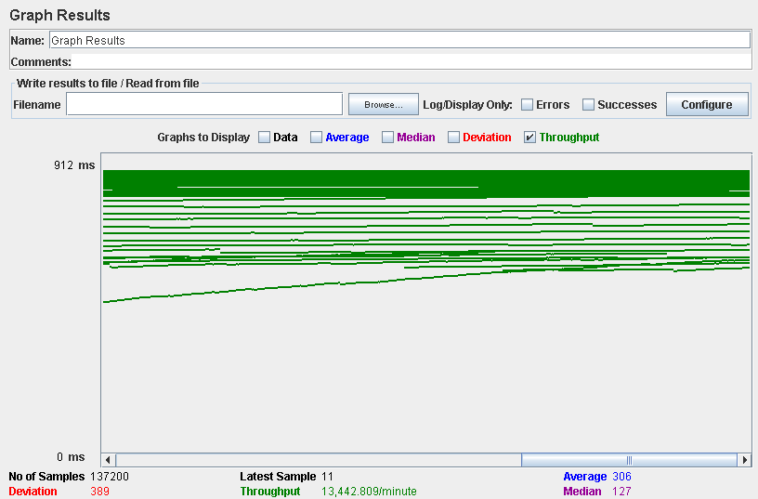

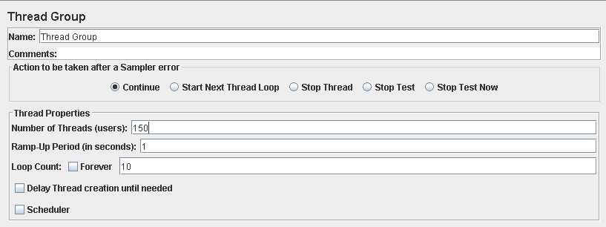

Performance test 90% results: Total 14,076s.

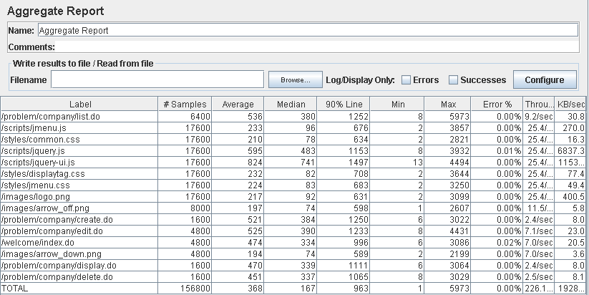

Performance thread results: 13,565 per minute.

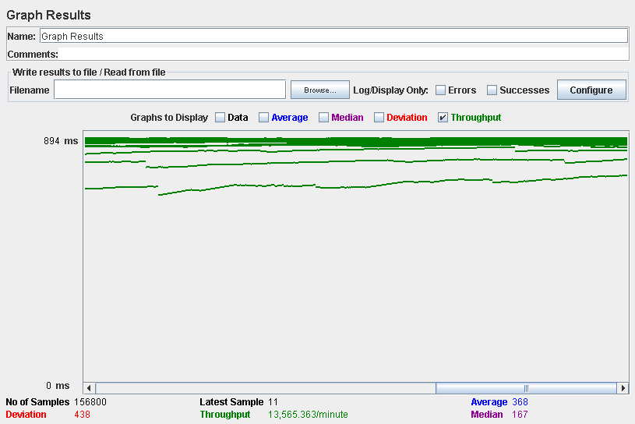

Computer performance:

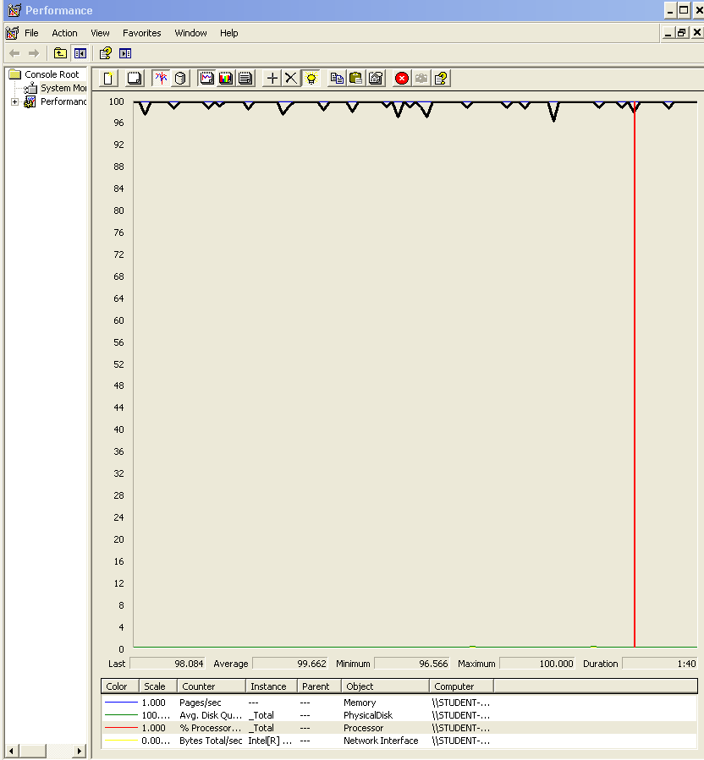

### Analysis results:

100 users and 10 loops: the application runs perfectly

140 users and 10 loops: the application runs perfectly too.

150 users and 10 loops: the application begins to have errors, the computer performance shows a memory bottleneck problem.

## Requisite: 9.3

9.3. Manage the applications to their positions, which includes listing them grouped by status, showing them, and updating them. Updating an application amounts to making a decision on it: an application whose status is SUBMITTED may change to status ACCEPTED or REJECTED.

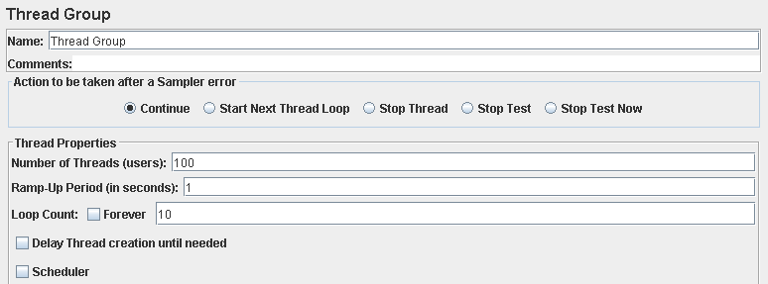

Performance test 90% results: Total 4,067s.

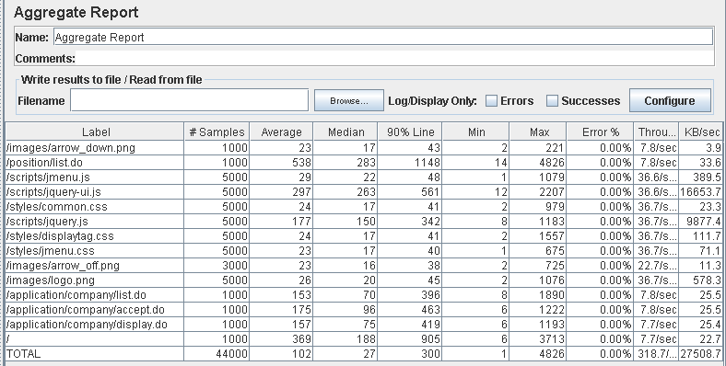

Performance thread results: 19,120 per minute

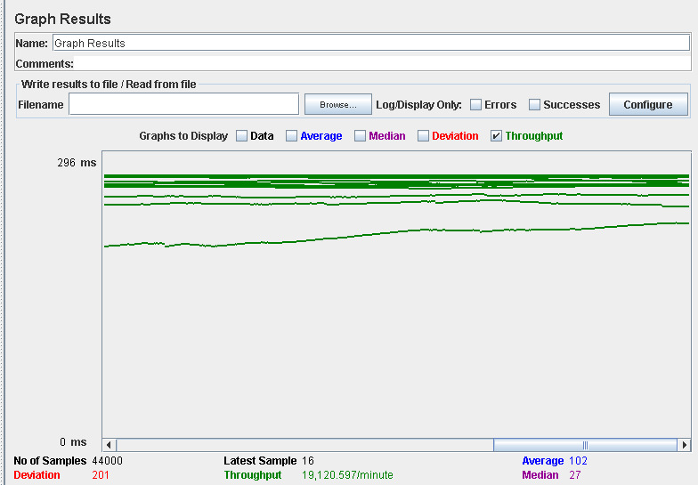

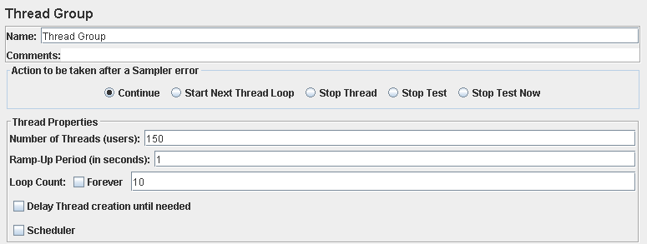

Performance test 90% results: Total 8,164s.

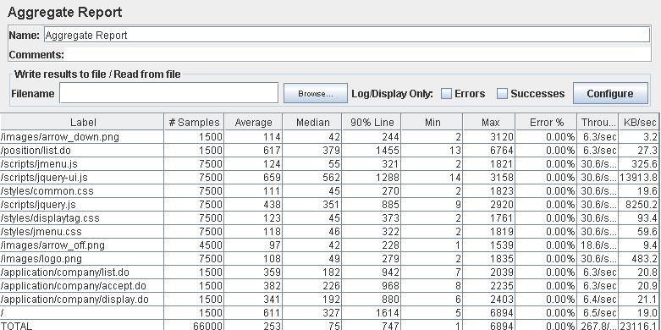

Performance thread results: 16,066 per minute.

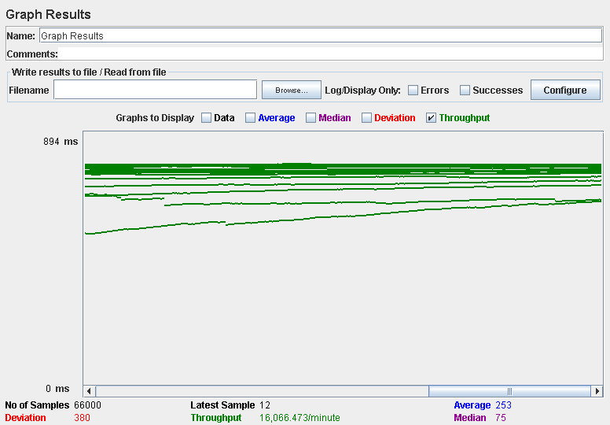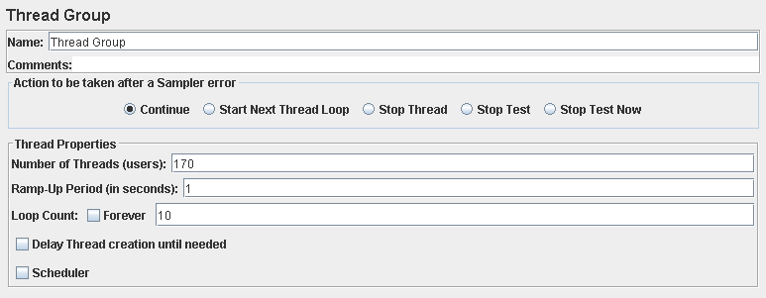

Performance test 90% results: Total 13,850s.

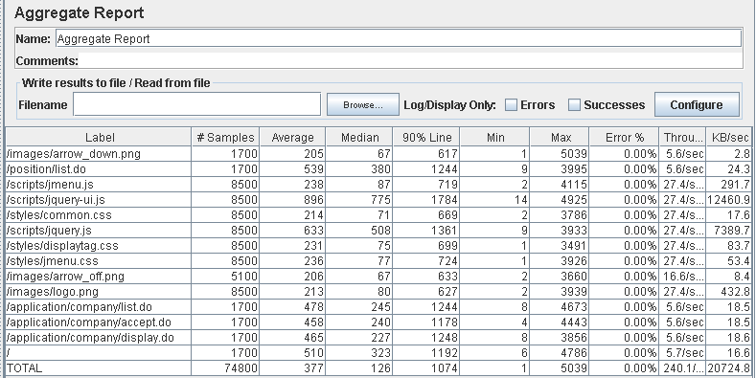

Performance thread results: 14,404 per minute.

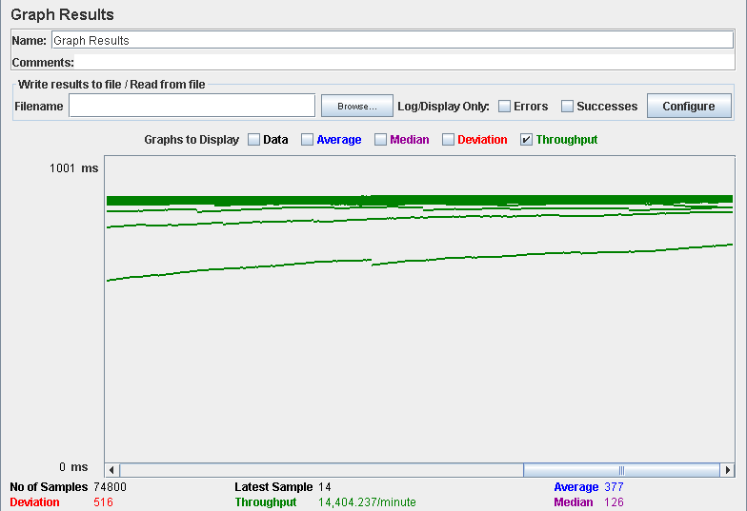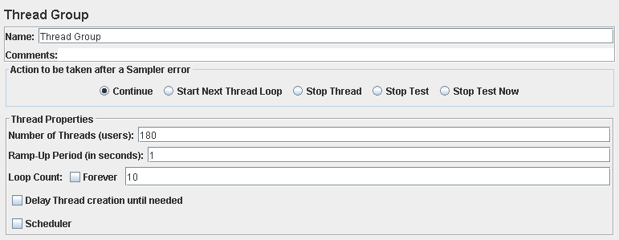

Performance test 90% results: Total 14,206s.

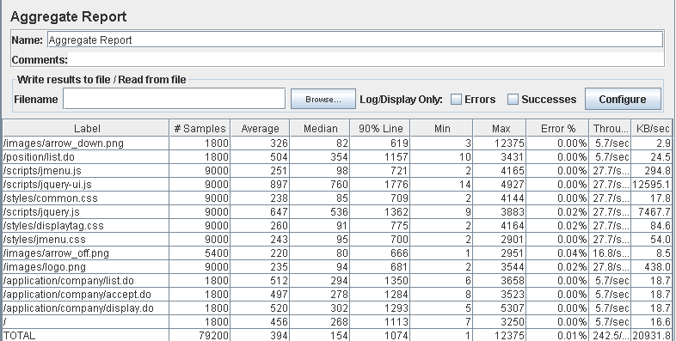

Performance thread results: 14,549 per minute.

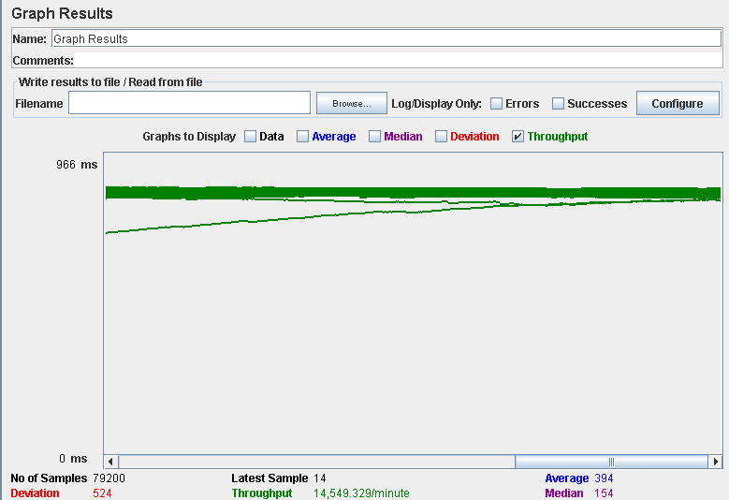

Computer performance:

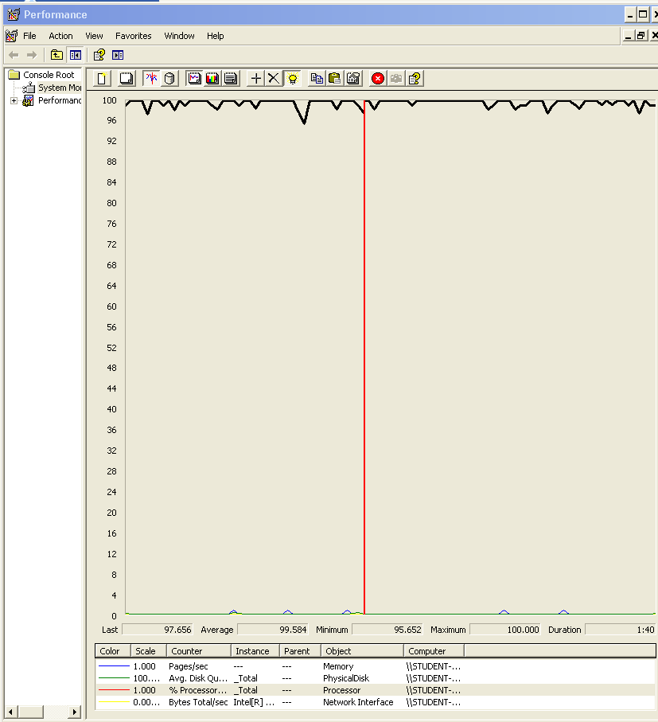

### Analysis results:

100 users and 10 loops: the application runs perfectly

150 users and 10 loops: the application runs perfectly too.

170 users and 10 loops: the application runs perfectly too.

180 users and 10 loops: the application begins to have errors, the computer performance analysis shows it could be a processors bottleneck problem.

## Requisite: 10

10. An actor who is authenticated as a hacker must be able to:

1. Manage his or her applications, which includes listing them grouped by status, showing them, creating them, and updating them. When an application is created, the system assigns an arbitrary problem to it (from the set of problems that have been registered for the corresponding position). Updating an application consists in submitting a solution to the corresponding problem (a piece of text with explanations and a link to the code), registering the submission moment, and changing the status to SUBMITTED.

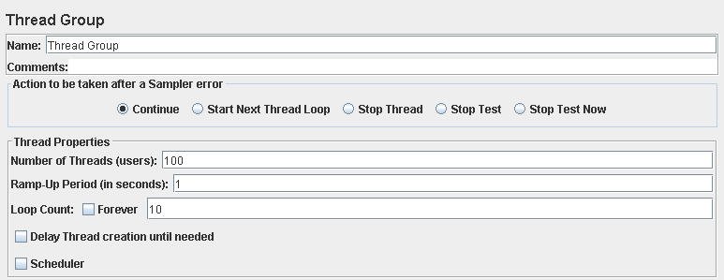

Performance test 90% results: Total 3,531s.

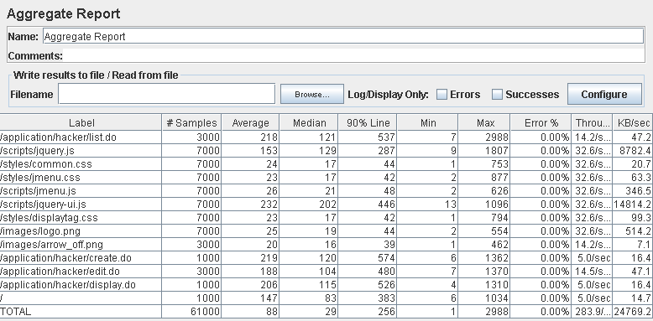

Performance thread results: 17,036 per minute.

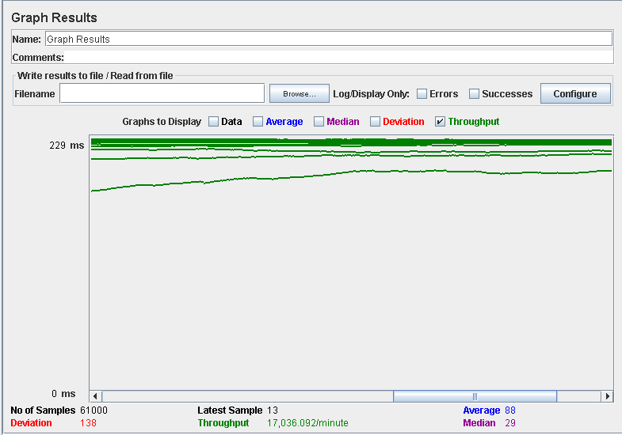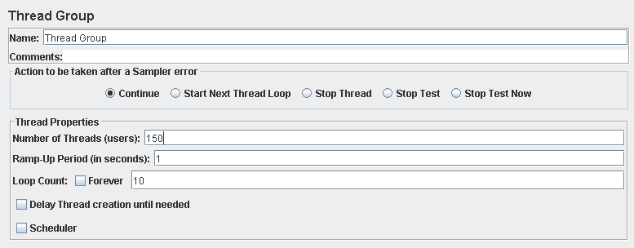

Performance test 90% results: Total 5,745s.

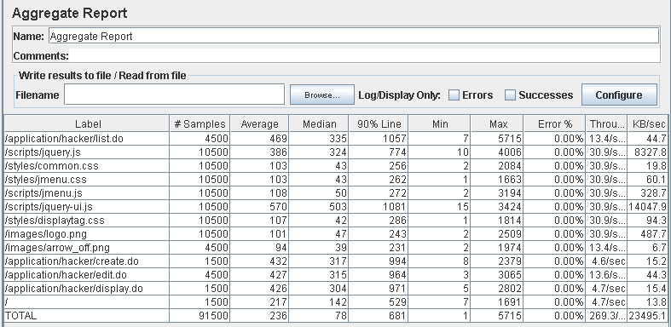

Performance thread results: 16,158 per minute.

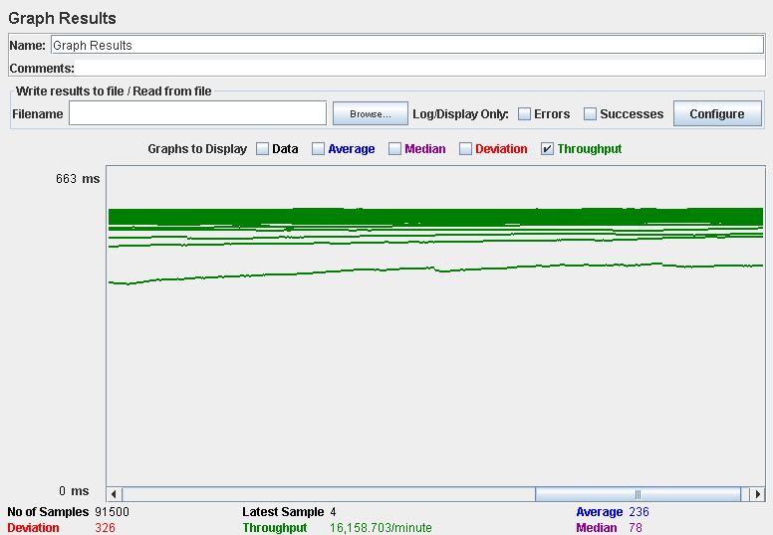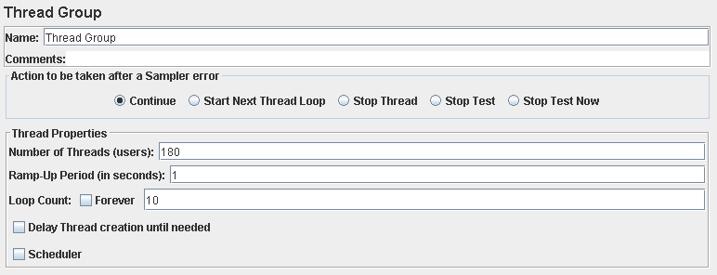

Performance test 90% results: Total 10,085s.

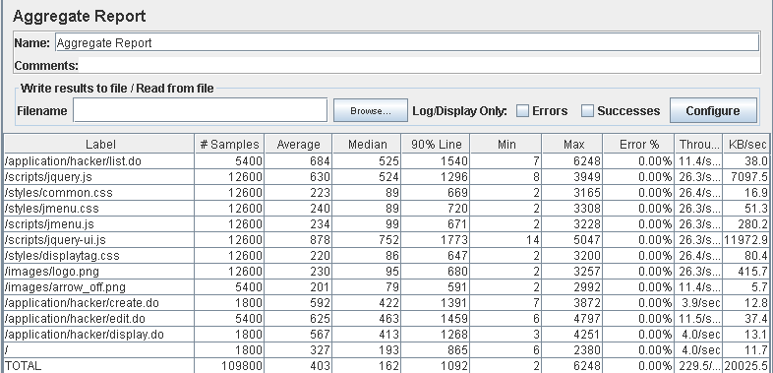

Performance thread results: 13,772 per minute.

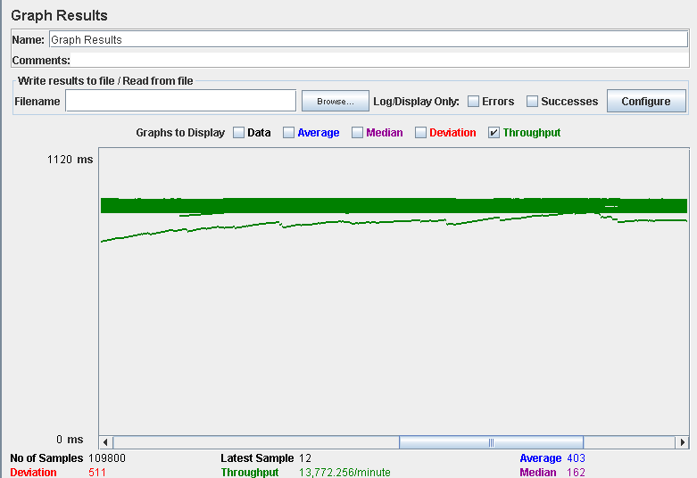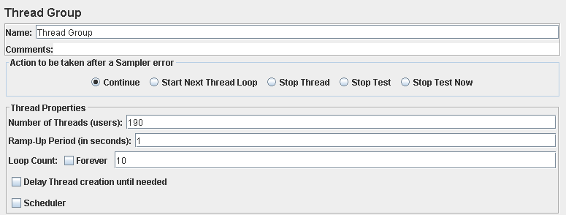

Performance test 90% results: Total 16,452s.

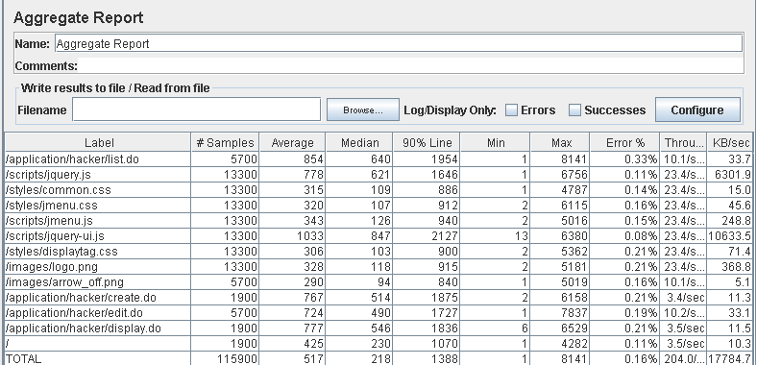

Performance thread results: 12,242 per minute.

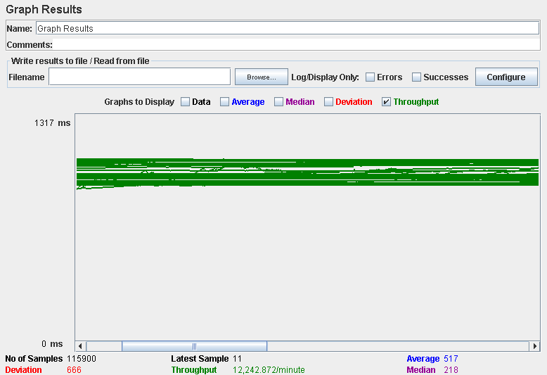

Computer performance:

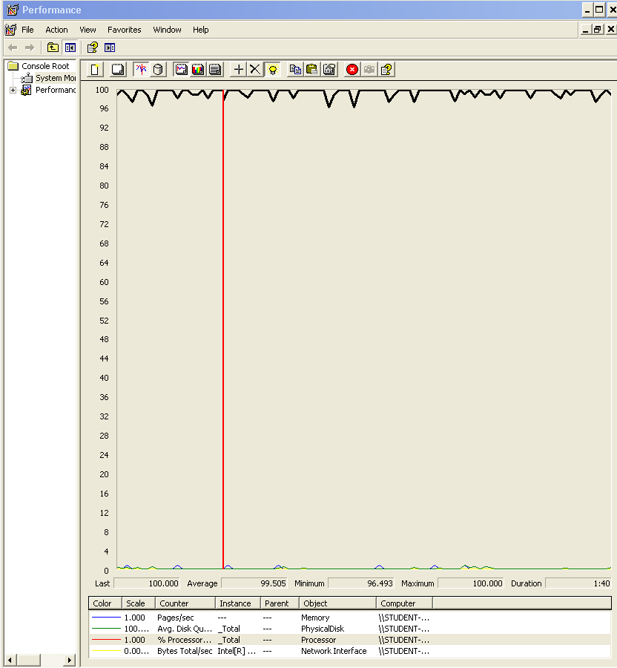

### Analysis results:

100 users and 10 loops: the application runs perfectly.

150 users and 10 loops: the application runs perfectly.

180 users and 10 loops: the application runs perfectly.

190 users and 10 loops: the application begins to have errors, the computer performance analysis shows it could be a processors bottleneck problem.

## Requisites: 11.1, 11.2, 18.1

11. An actor who is authenticated as an administrator must be able to:

1. Create user accounts for new administrators.

2. Display a dashboard with the following information:

* The average, the minimum, the maximum, and the standard deviation of the number of positions per company.
* The average, the minimum, the maximum, and the standard deviation of the number of applications per hacker.
* The companies that have offered more positions.
* The hackers who have made more applications.
* The average, the minimum, the maximum, and the standard deviation of the salaries offered.
* The best and the worst position in terms of salary.

18. An actor who is authenticated as an administrator must be able to:

1. Display a dashboard with the following information:

* The minimum, the maximum, the average, and the standard deviation of the number of curricula per hacker.
* The minimum, the maximum, the average, and the standard deviation of the number of results in the finders.
* The ratio of empty versus non-empty finders.

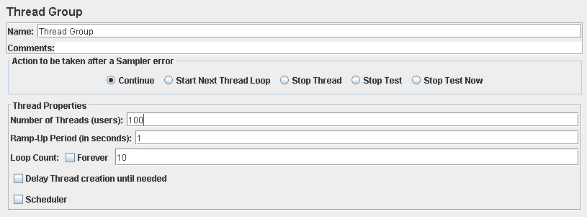

Performance test 90% results: Total 11,393s.

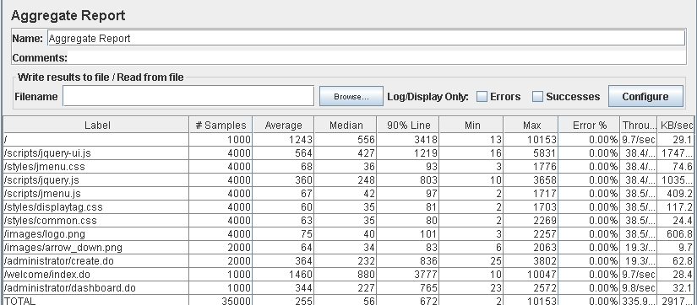

Performance thread results: 20,152 per minute.

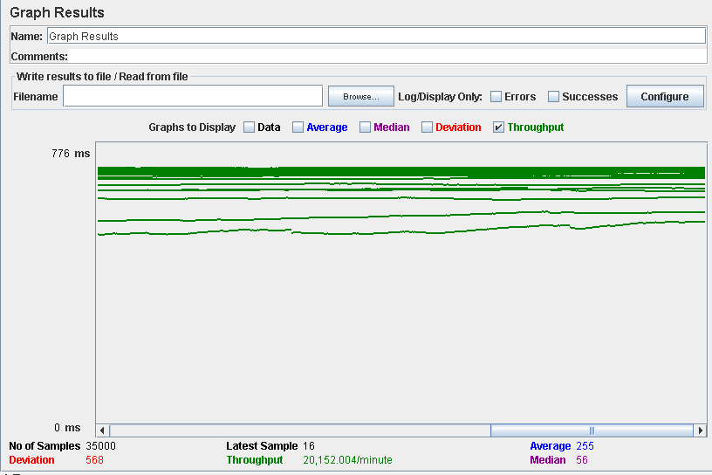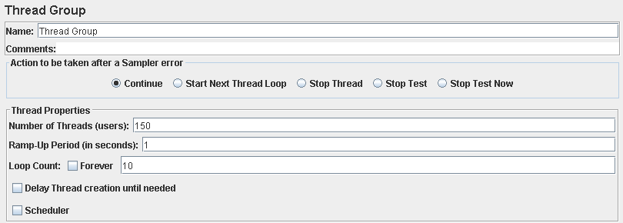

Performance test 90% results: Total 7,902s.

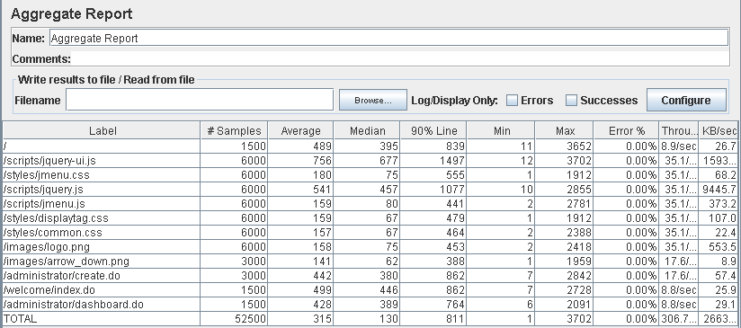

Performance thread results: 18,283 per minute.

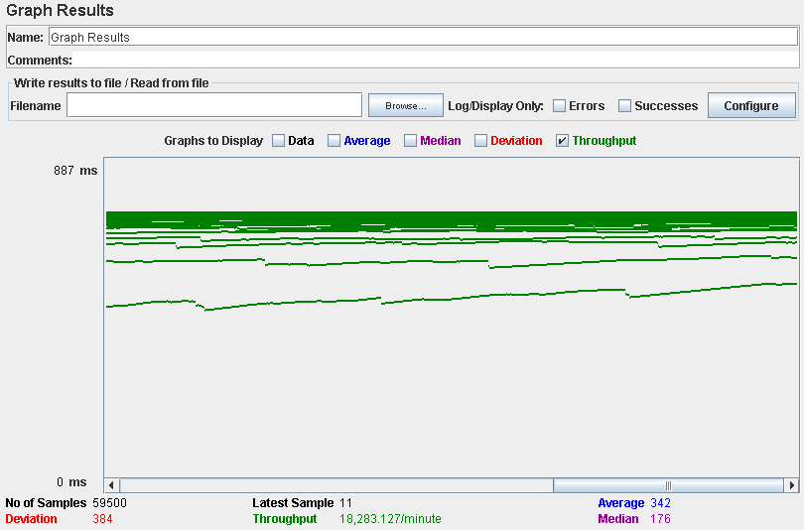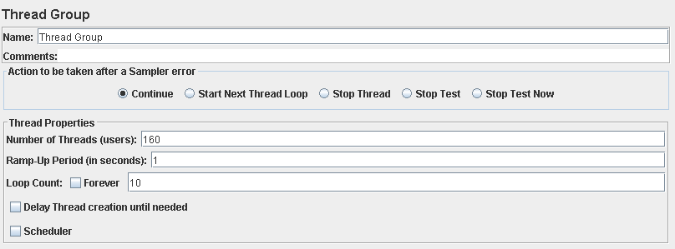

Performance test 90% results: Total 13,993s.

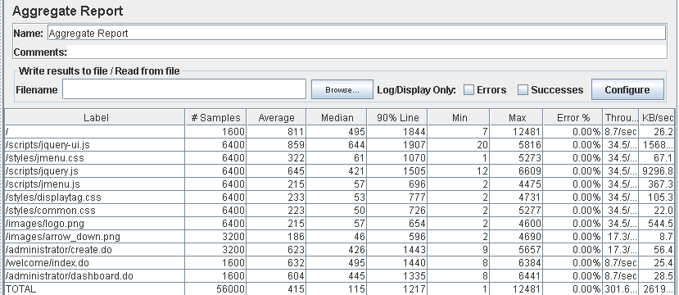

Performance thread results: 18,907 per minute.

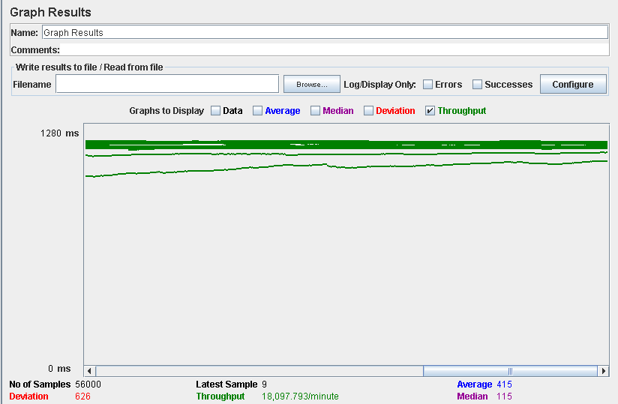

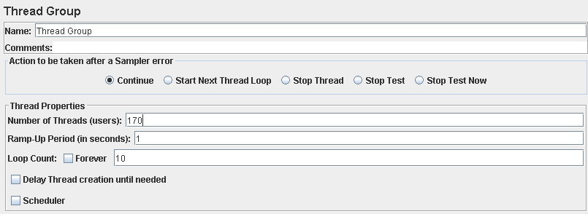

Performance test 90% results: Total 10,104s.

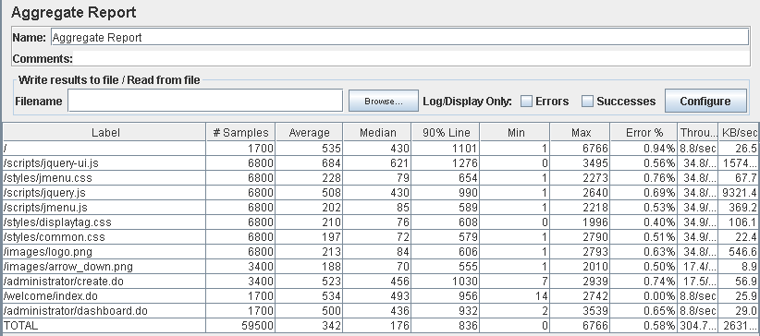

Performance thread results: 18,400 per minute.

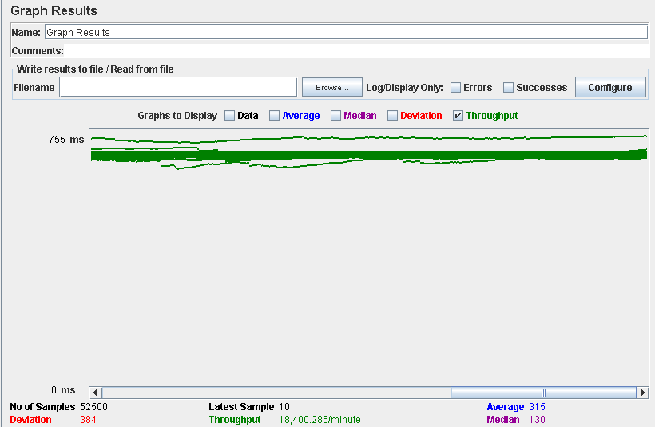

Computer performance:

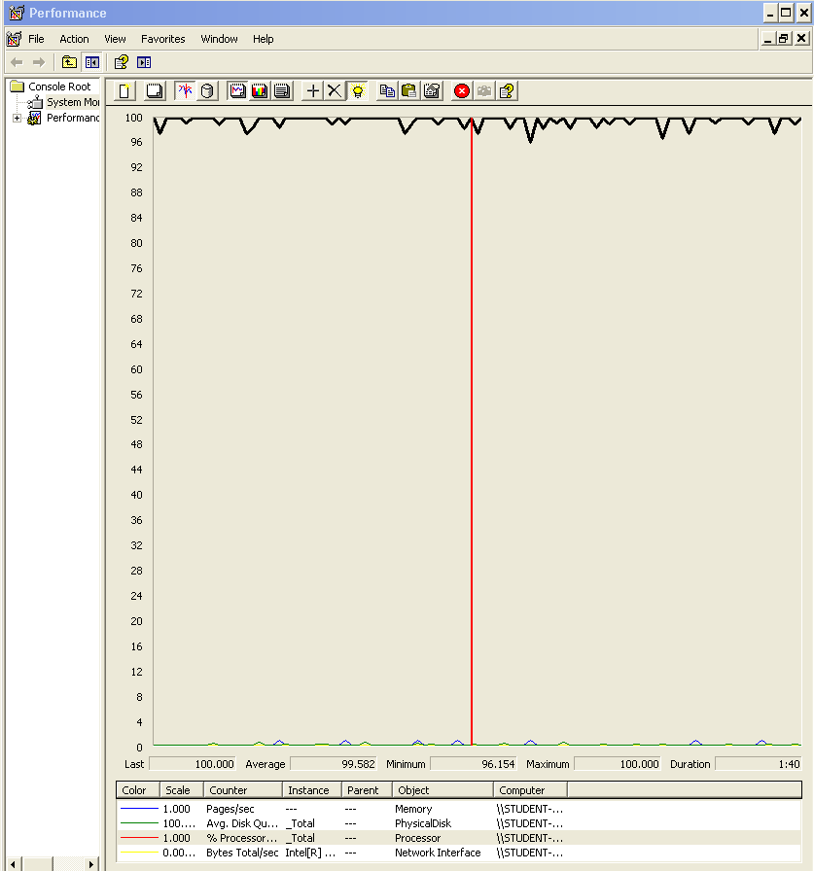

### Analysis results:

100 users and 10 loops: the application runs well, the times are a bit high sometimes butt is fixed somehow with 150 users, could be that the computer was doing another tasks under the system.

150 users and 10 loops: the application runs perfectly.

160 users and 10 loops: the application runs perfectly.

170 users and 10 loops: the application begins to have errors, the computer performance analysis shows it could be a processors bottleneck problem.

## Requisite: 17.1

17. An actor who is authenticated as a hacker must be able to:

1. Manage his or her curricula, which includes listing, showing, creating, updating, and deleting them. When a hacker makes an application, he or she must select one of his or her curricula so that it’s attached to the application. Note that attaching a curriculum makes a copy; the updates that a hacker performs on the original curriculum are not propagated to the applications to which he or she’s attached a previous version.

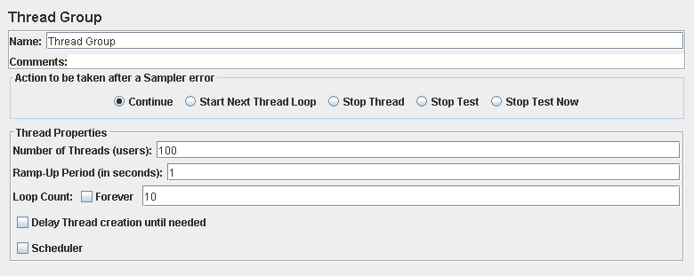

Performance test 90% results: Total 4,302s.

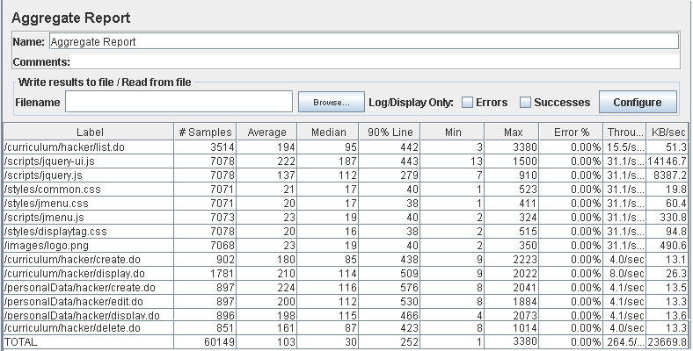

Performance thread results: 15,324 per minute.

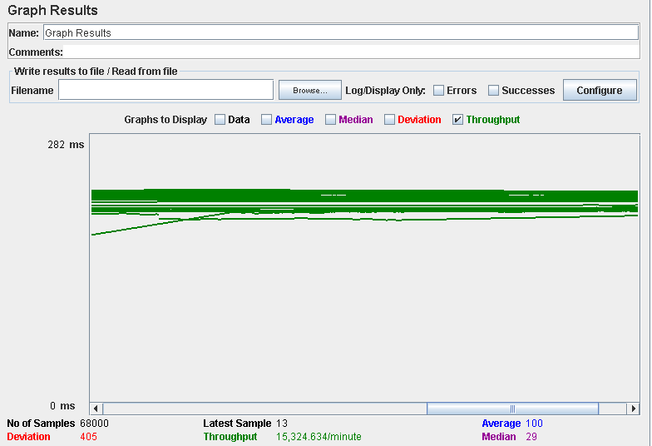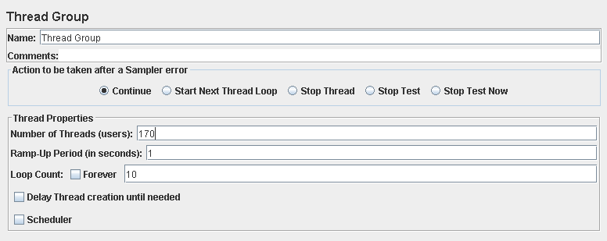

Performance test 90% results: Total 14,270s.

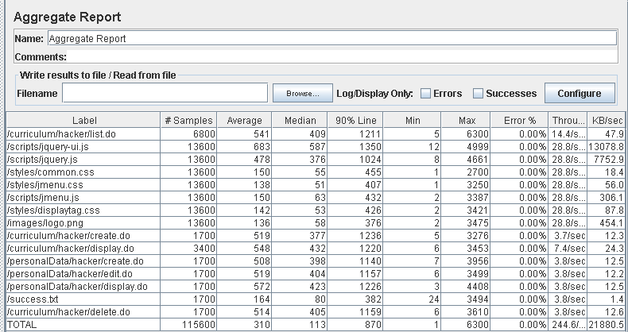

Performance thread results: 14,674 per minute.

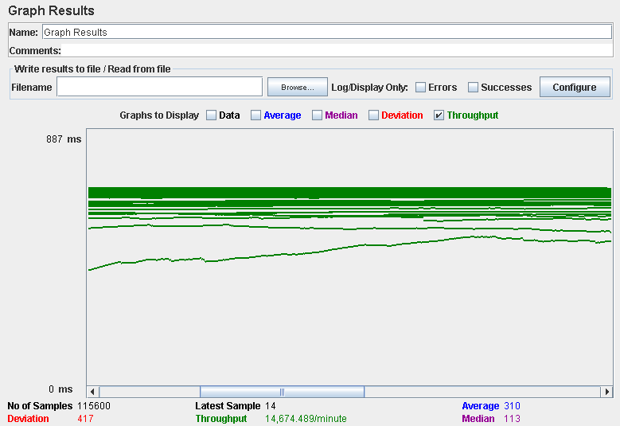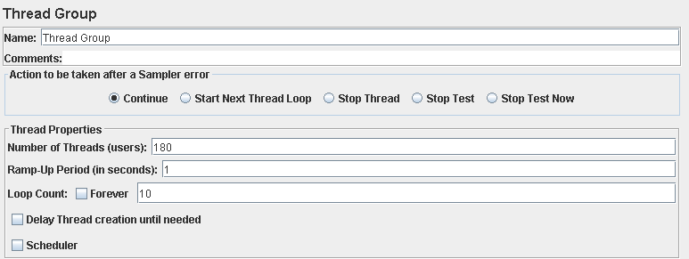

Performance test 90% results: Total 17,227s.

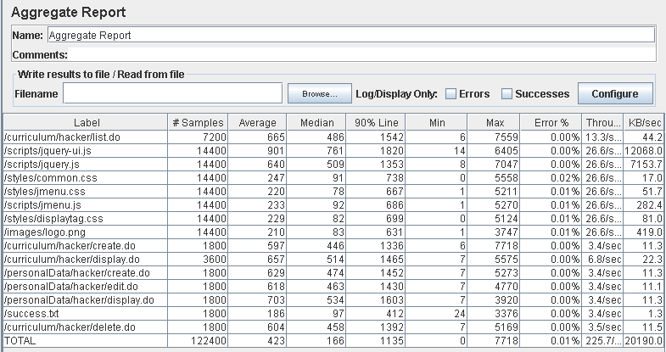

Performance thread results: 13,540 per minute.

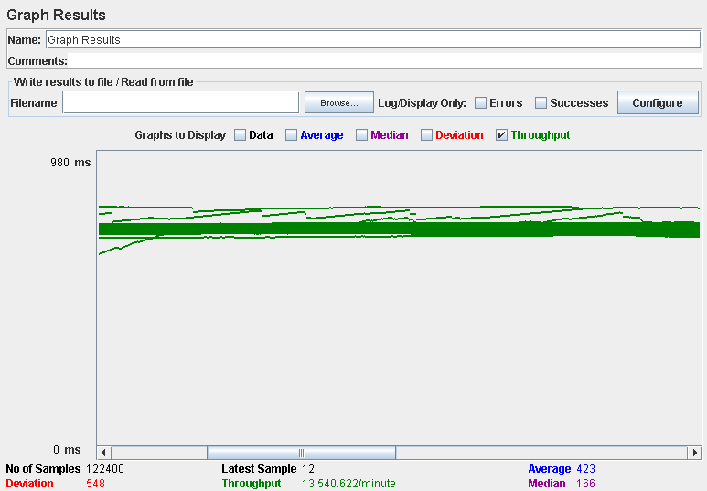

Computer performance:

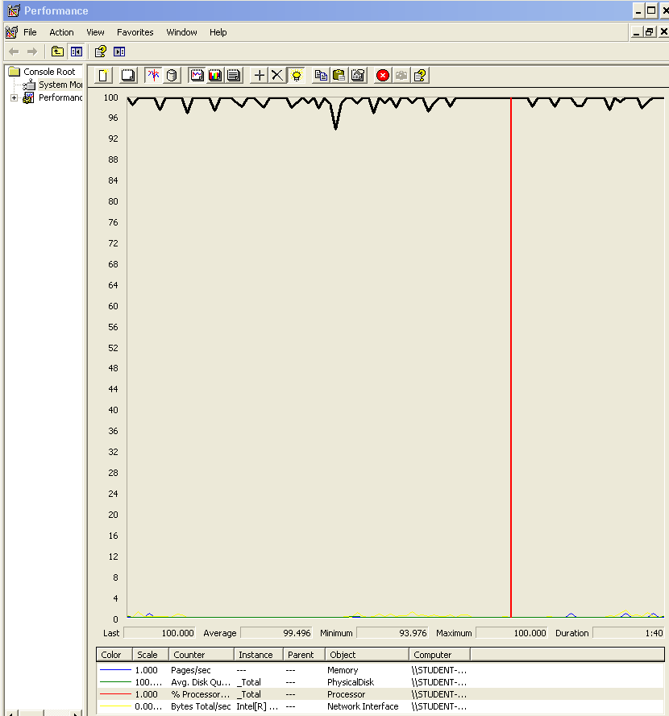

### Analysis results:

100 users and 10 loops: the application runs perfectly.

170 users and 10 loops: the application runs perfectly.

180 users and 10 loops: the application begins to have errors, the computer performance analysis shows it could be a processors bottleneck problem.

## Requisite: 17.2

17. An actor who is authenticated as a hacker must be able to:

2. Manage his or her finder, which involves updating the search criteria, listing its contents, and clearing it.

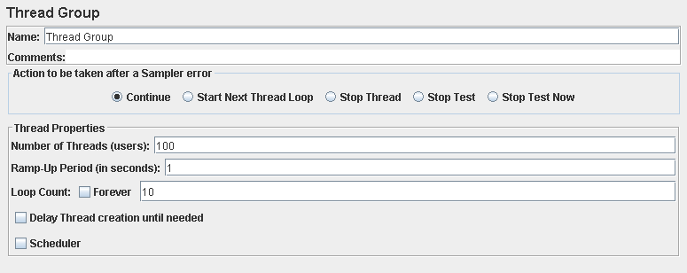

Performance test 90% results: Total 2,464s.

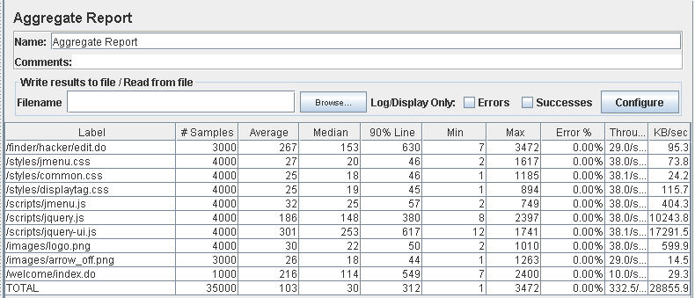

Performance thread results: 19,949 per minute.

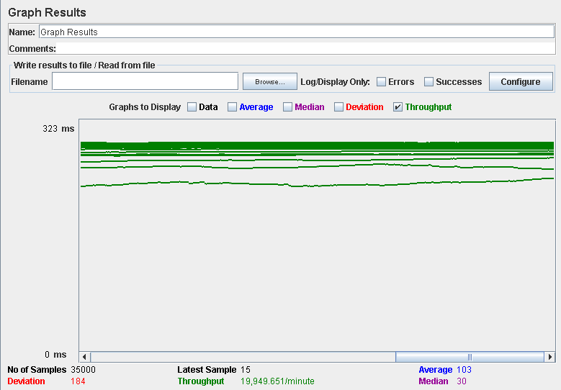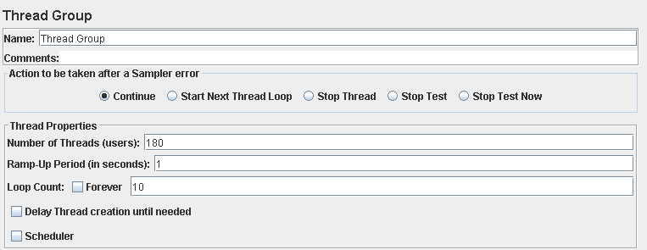

Performance test 90% results: Total 9,587s.

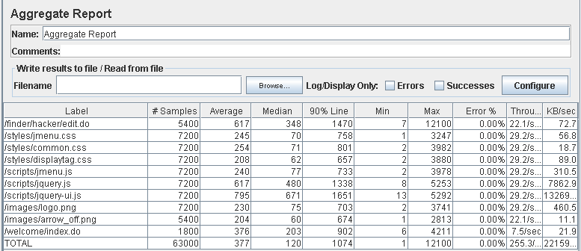

Performance thread results: 15,318 per minute.

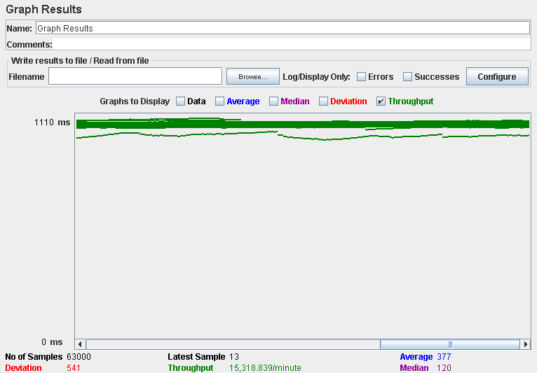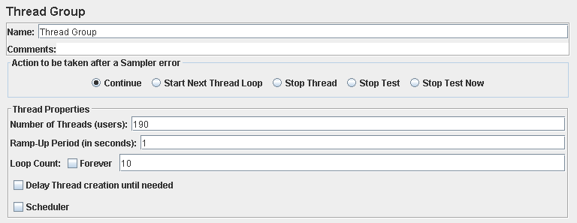

Performance test 90% results: Total 9.655s.

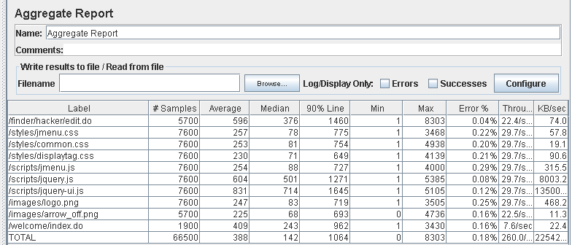

Performance thread results: 15,600 per minute.

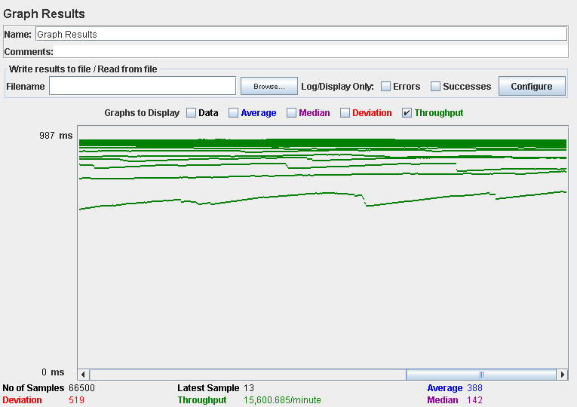

Computer performance:

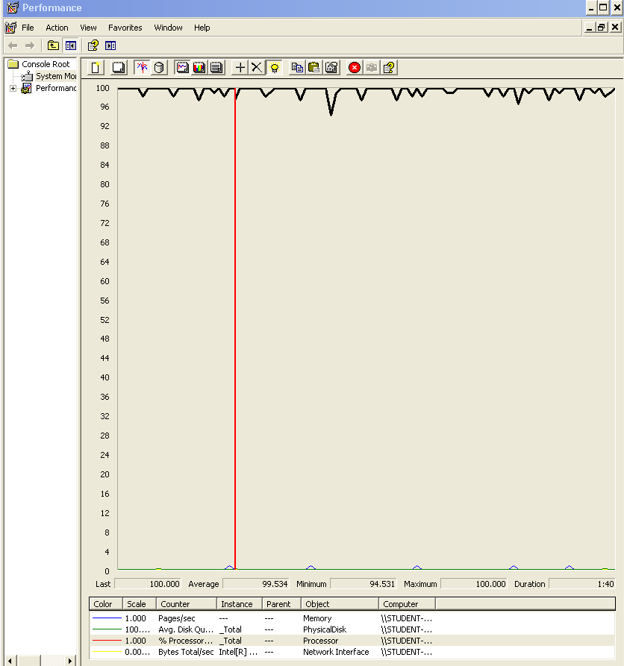

### Analysis results:

100 users and 10 loops: the application runs perfectly.

180 users and 10 loops: the application runs perfectly.

190 users and 10 loops: the application begins to have errors, the computer performance analysis shows it could be a processors bottleneck problem.

## Requisite: 23.1

23. An actor who is authenticated must be able to:

1. Manage his or her social profiles, which includes listing, showing, creating, updating, and deleting them.

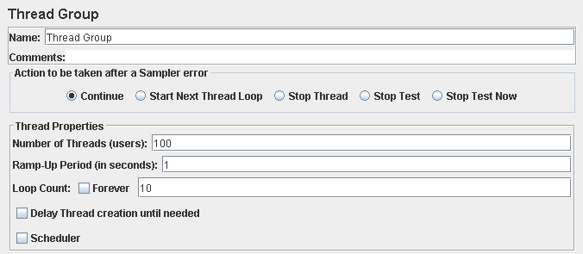

Performance test 90% results: Total 3,399s.

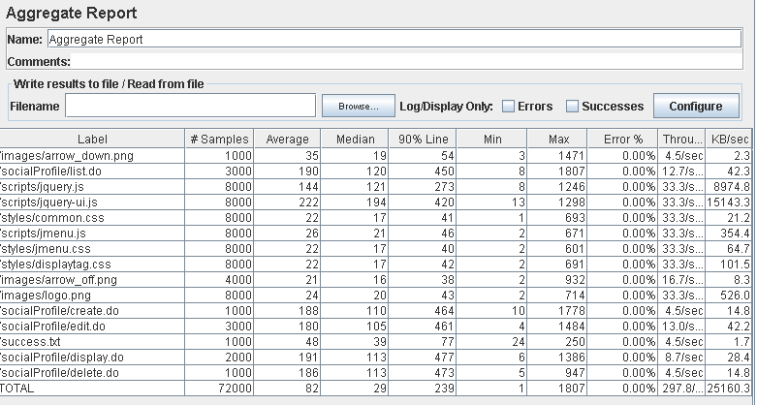

Performance thread results: 17,780 per minute.

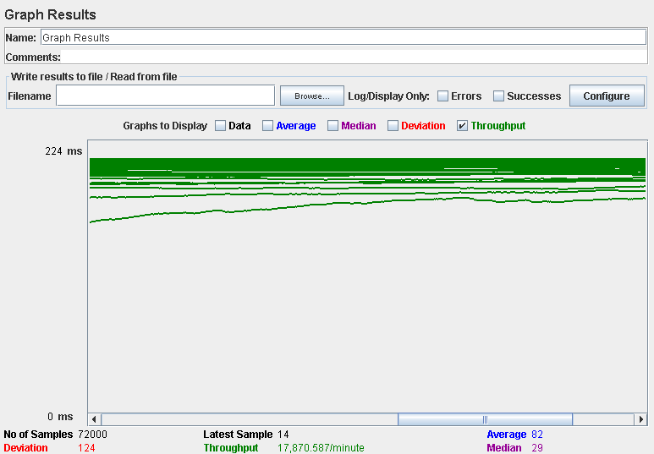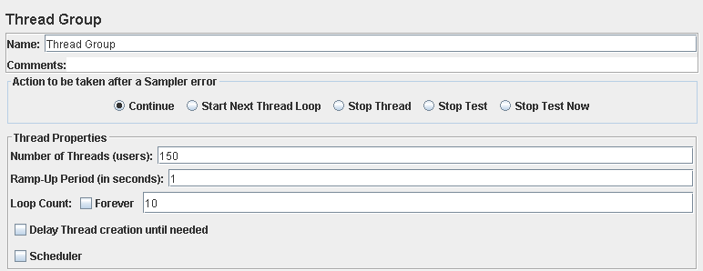

Performance test 90% results: Total 8,147s.

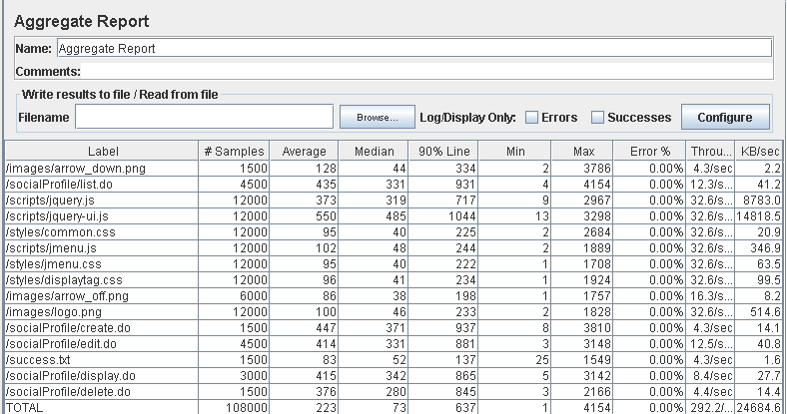

Performance thread results: 17,531 per minute.

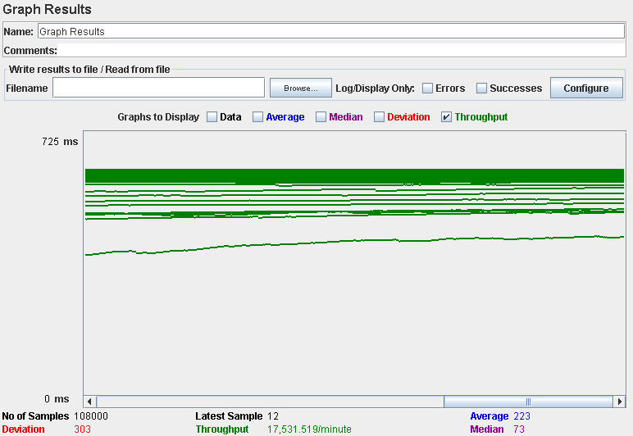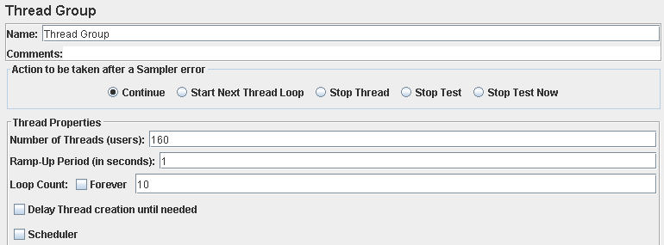

Performance test 90% results: Total 10,816s.

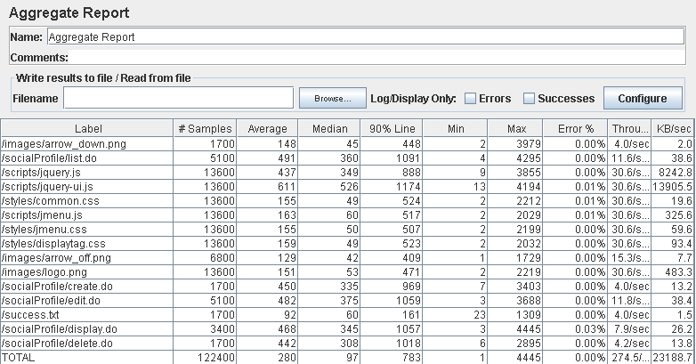

Performance thread results: 16,469 per minute.

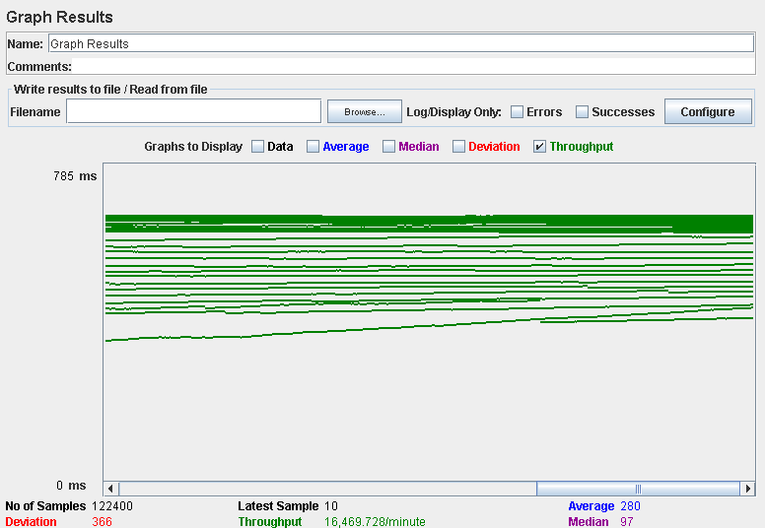

Computer performance:

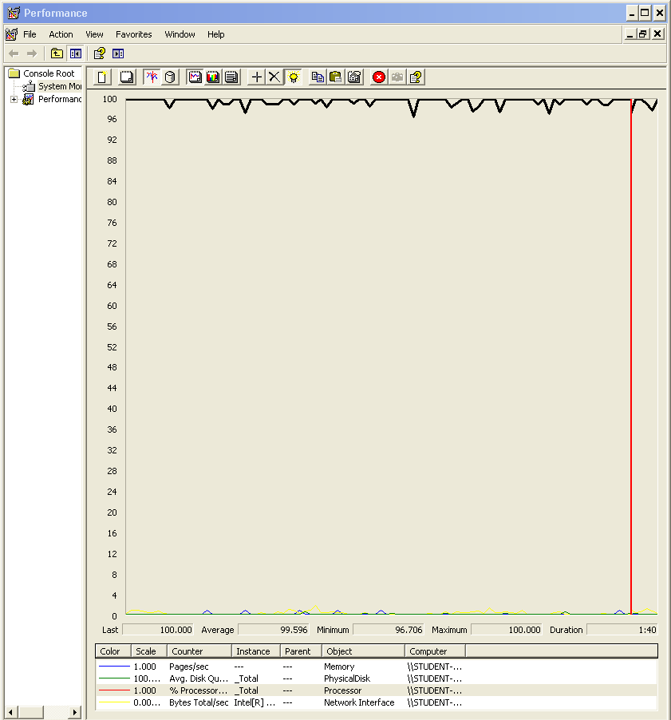

### Analysis results:

100 users and 10 loops: the application runs perfectly.

150 users and 10 loops: the application runs perfectly.

160 users and 10 loops: the application begins to have errors, the computer performance analysis shows it could be a processors bottleneck problem.

## Requisite: 23.2

23. An actor who is authenticated must be able to:

2. Manage his or her messages, which includes listing them grouped by tag, showing them, sending a message to an actor, deleting a message that he or she’s got. If a message is deleted and it doesn’t have tag “DELETED” then it gets tag “DELETED”, but it’s not actually deleted from the system; if a message with tag “DELETED” is deleted, then it’s actually removed from the system.

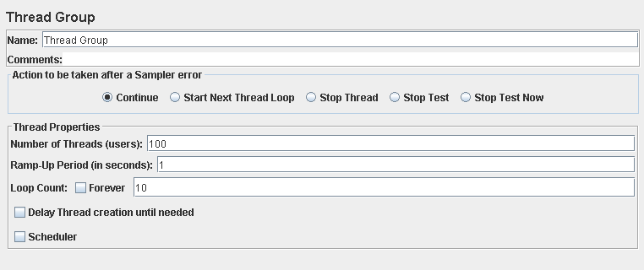

Performance test 90% results: Total 1,226s.

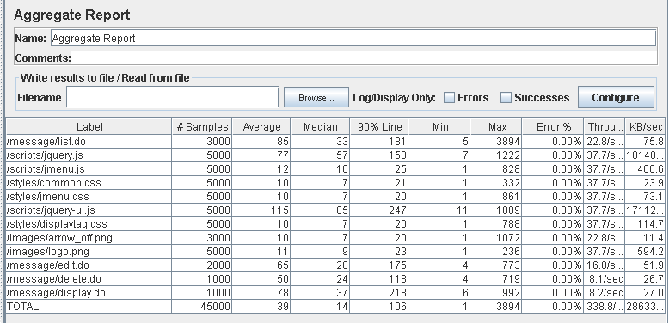

Performance thread results: 20,325 per minute.

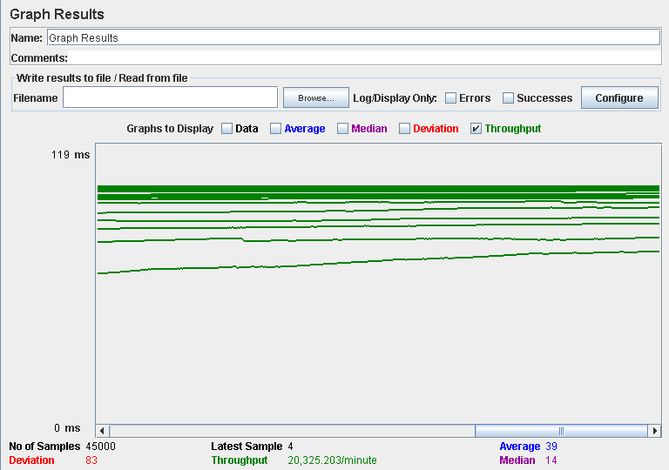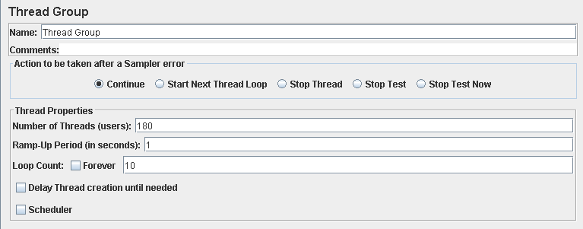

Performance test 90% results: Total 11,148s.

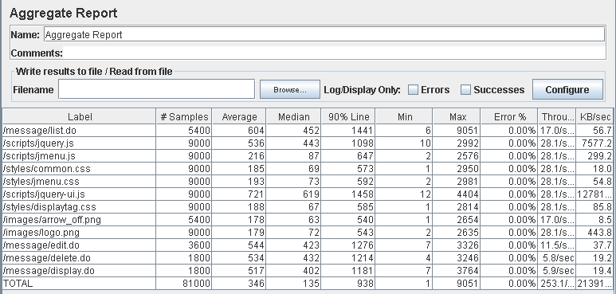

Performance thread results: 15,183 per minute.

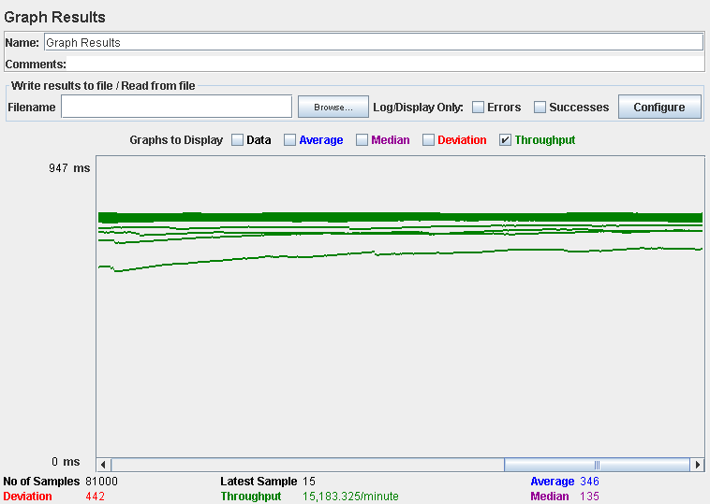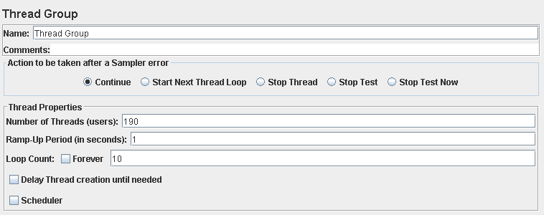

Performance test 90% results: Total 11,654s.

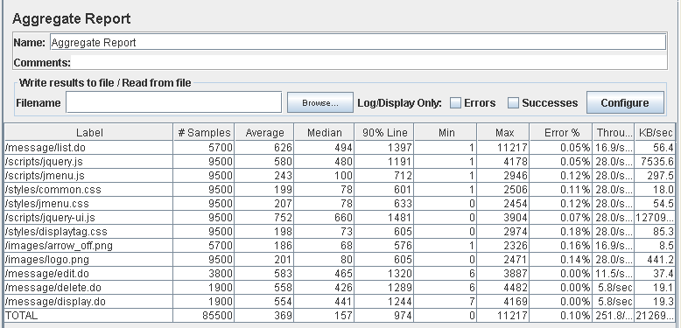

Performance thread results: 15,106 per minute.

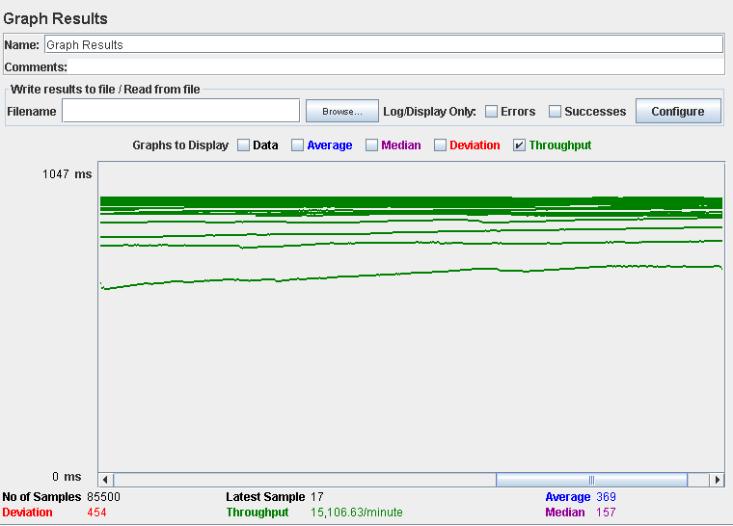

Computer performance:

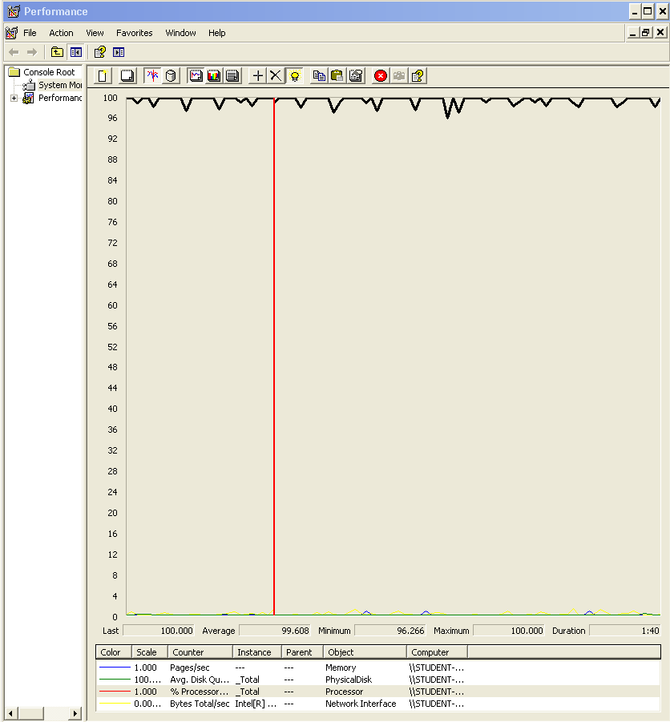

### Analysis results:

100 users and 10 loops: the application runs perfectly.

180 users and 10 loops: the application runs perfectly.

190 users and 10 loops: the application begins to have errors, the computer performance analysis shows it could be a processors bottleneck problem.

## Requisite: 24.1. 24.2, 24.3, 24.4

24. An actor who is authenticated as an administrator must be able to:

1. Broadcast a notification message to the actors of the system. The message must have tag “SYSTEM” by default.

2. Launch a process that flags the actors of the system as spammers or not-spammers. A user is considered to be a spammer if at least 10% of the messages that he or she’s sent contain at least one spam word.

3. Ban an actor with the spammer flag.

4. Unban an actor who was banned previously.

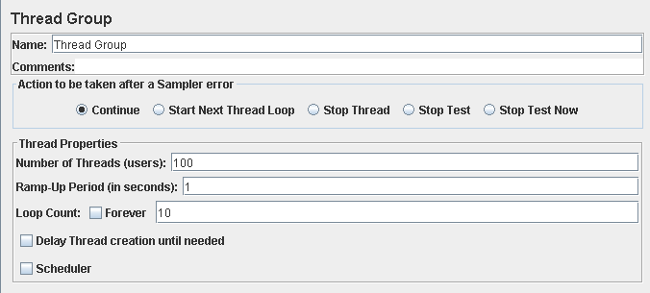

Performance test 90% results: Total 3,300s.

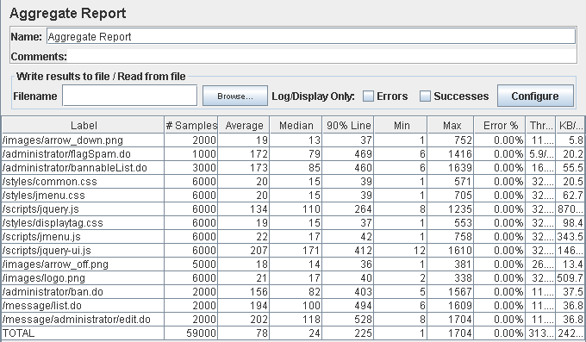

Performance thread results: 18,789 per minute.

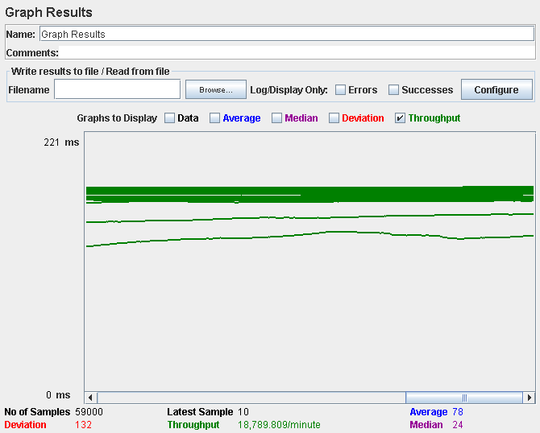

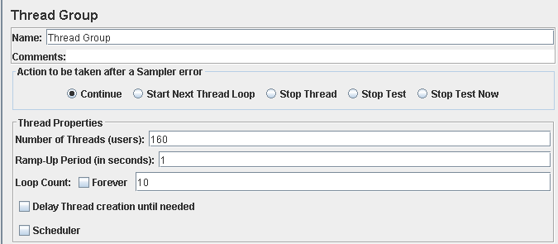

Performance test 90% results: Total 9,987s.

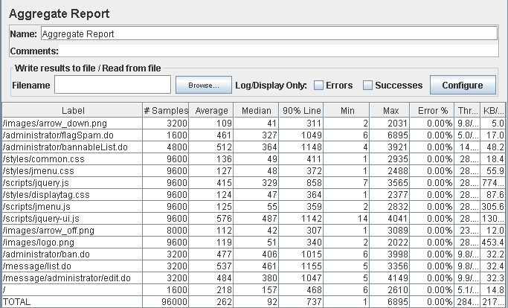

Performance thread results: 17,085 per minute.

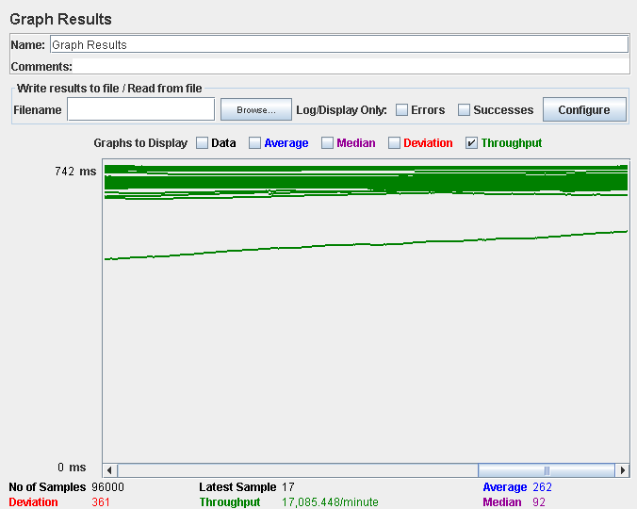

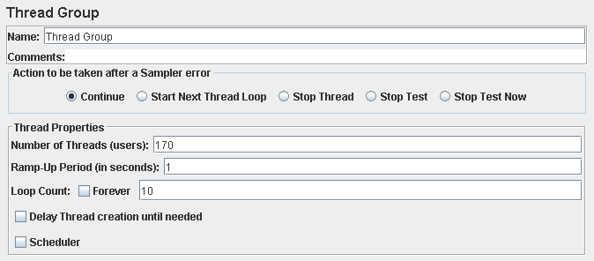

Performance test 90% results: Total 15,440s.

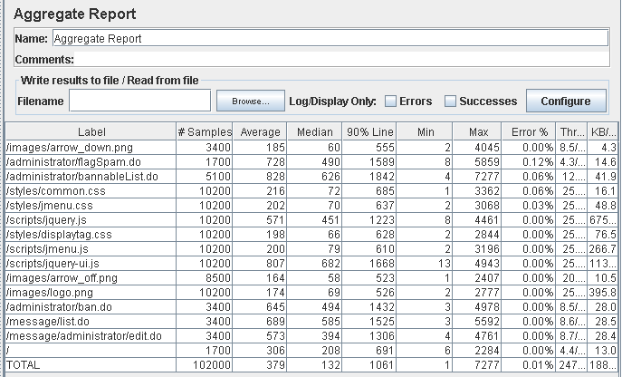

Performance thread results: 14,859 per minute.

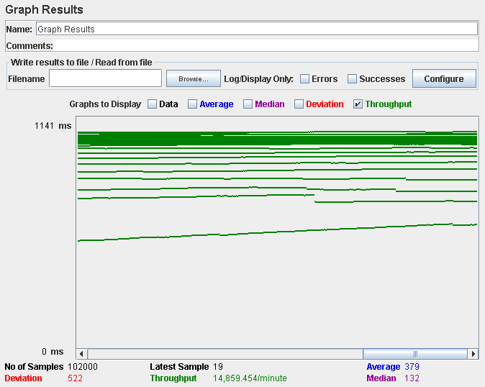

Computer performance:

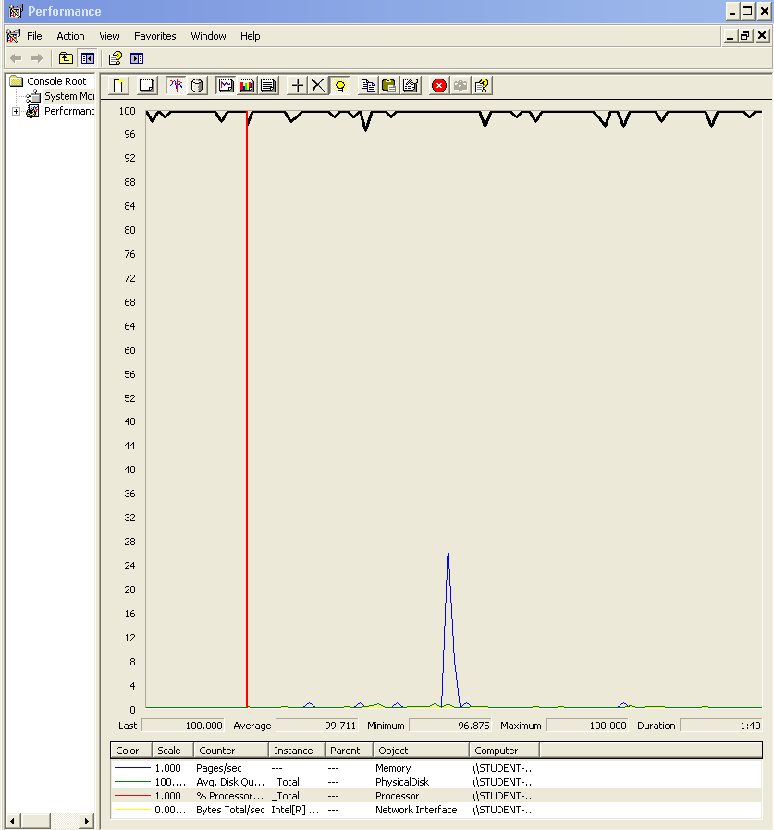

# Analysis results:

100 users and 10 loops: the application runs perfectly.

160 users and 10 loops: the application runs perfectly.

170 users and 10 loops: the application begins to have errors, the computer performance analysis shows it could be a processors bottleneck problem.

# Conclusion

After the analysis of all the test realized, we can say that for 100 users and 10 loops all of our tests were successful, without any errors or excessive answer time.

It seems that from 150 users the system could encounter some errors due to the processor or memory (in most cases was the processor), either because the answer time was more than 3 seconds or because there wasn’t a success answer from the website.

We believe that with 140 users the system will answer correctly without errors or excessive answers times that could affect the user experience.

Changing the processor for a better one could mean an improvement in the number of concurrent users and after this change maybe a memory upgrade would be the way to go to continue increasing the allowed users.